**A Project Report on**

**Determination of the factors affecting investors' decision making process in cryptocurrency investment in India**

**submitted to the Osmania University**



**in partial fulfillment of the requirements for the award of the degree of**

**Bachelor of Business Administration**

**By**

**Kolanu Rohith Reddy (Hall Ticket No.: 120919684004)**

**Under the guidance of**

**Ms. Payal Pattnayak Lecturer**

**St. Mary’s College (Affiliated to Osmania University)**

**8-3-229, Near Yousufguda Check post, Yousufguda, Hyderabad, Telangana – 500045, India**

**June 2022**



**St. Mary’s College**

(Affiliated to Osmania University)

8-3-229, Near Yousufguda Check post, Yousufguda, Hyderabad, Telangana – 500045, India

**DECLARATION**

I hereby declare that the Project Work entitled **“Determination of the factors affecting investors' decision making process in cryptocurrency investment in India”** submitted in partial fulfillment of the requirements for the award of the degree of

Bachelor of Business Administration to the Osmania University through St. Mary’s College, Yousufguda, Hyderabad – 45 is my original work and no part of the project has formed the basis for the award of any degree, diploma, or certificate and the project, in full or in part, has till date not been submitted to any other University or Institution, for credits or for any other recognition.

**Signature of the Student**

**Date: June 2022 Kolanu Rohith Reddy**

**Hyderabad Hall Ticket No.: 120919684004**



**St. Mary’s College**

(Affiliated to Osmania University)

8-3-229, Near Yousufguda Check post, Yousufguda, Hyderabad, Telangana – 500045, India

**CERTIFICATE**

This is to certify that the project work entitled **“Determination of the factors affecting investors' decision making process in cryptocurrency investment in India”** that is being submitted by **Kolanu Rohith Reddy** in partial fulfillment of the requirements for the award of the degree of Bachelor of Business Administration to the Osmania University through St. Mary’s College, Yousufguda, Hyderabad – 45 is a record of *bonafide* work carried out by him under my guidance and supervision. The work embodied in this project report has not been submitted to any other University or Institute for the award of any degree, diploma, or certificate.

**Signature of Supervisor**

**Date: June 2022 Ms. Payal Pattnayak**

**Hyderabad Lecturer**

Approved for submission to the University.

**Signature of HoD Mr. M. Bobby**

**Head, Department of Management**

List of Tables List of Figures

## INDEX

|  |  |  |
| --- | --- | --- |
| **Chapter No** | **Description** | **Page No** |
| 1 | Introduction | 1 - 8 |
| 2 | Review of Literature | 9 - 22 |
| 3 | Industry Profile | 23 - 33 |
| 4 | Company Profile | 34 - 44 |
| 5 | Conceptual Framework | 45 - 52 |
| 6 | Data Analysis | 53 - 73 |
| 7 | Findings, Suggestions, & Conclusions | 74 - 77 |
|  | Bibliography | 78 - 81 |
|  | Appendix | 82 - 86 |

**List of Tables**

|  |  |  |
| --- | --- | --- |
| **Table No** | **Name** | **Page No** |
| 6.1 | Gender | 54 |
| 6.2 | Age | 55 |
| 6.3 | Cryptocurrencies | 66 |
| 6.4 | Platform | 68 |

**List of Figures**

|  |  |  |
| --- | --- | --- |
| **Figure No** | **Name** | **Page No** |
| 3.1 | Operation of Cryptocurrency | 27 |
| 4.1 | Bitcoin functioning | 36 |
| 4.2 | Transaction volume of Bitcoin | 38 |
| 4.3 | Ethereum security | 41 |
| 5.1 | Intention to use Cryptocurrencies | 49 |
| 6.1 | Gender | 54 |
| 6.2 | Age | 55 |
| 6.3 | Occupation | 56 |
| 6.4 | Annual personal income range | 56 |
| 6.5 | Respondent’s awareness about Cryptocurrencies | 57 |
| 6.6 | Ownership held by people in cryptocurrencies | 58 |

|  |  |  |
| --- | --- | --- |
| 6.7 | Medium of exposure | 58 |
| 6.8 | Reaction of people towards financial advice | 59 |
| 6.9 | Reason for investing in cryptocurrencies | 60 |
| 6.10 | Impact of dips on people | 60 |
| 6.11 | Loss bearing capacity of people | 61 |
| 6.12 | Willingness to buy | 62 |
| 6.13 | Willingness to buy diversified portfolio | 63 |
| 6.14 | Cryptocurrencies as store of value | 64 |
| 6.15 | Factors influencing investor’s decision | 65 |
| 6.16 | Future growth prospects | 65 |
| 6.17 | Speculation of future market leader | 66 |
| 6.18 | Use of Cryptocurrencies for illegal purposes | 67 |
| 6.19 | Platform preferences of people | 68 |
| 6.20 | Will Crypto eventually replace the current system? | 69 |
| 6.21 | Correlation analysis | 70 |
| 6.22 | Bitcoin historical performance | 71 |
| 6.23 | Ethereum historical performance | 72 |
| 6.24 | Competitive analysis | 73 |

# Chapter - 1 Introduction

## Introduction

This is a key to building an informational project report that includes certain elements and details about **Determination of the factors influencing investors' decision making process in cryptocurrency investments in India** with the special reference to **Bitcoin & Ethereum**. This project report makes an attempt to provide insights about the elements impacting investors' decision making in cryptocurrency investments, as well as its history.

Cryptocurrencies have received much interest over the last few years, with over 1,600 available as of 2018. And the figure is always rising. As a result, the need for blockchain developers has increased (the underlying technology of cryptocurrencies such as bitcoin). The wages of blockchain developers demonstrate how highly they are valued. The average full-stack developer pay is more than $112,000. There's even a website dedicated to bitcoin jobs.

Bitcoin and Ether are the biggest and most valuable cryptocurrencies right now. Both of them use blockchain technology, in which transactions are added to a container called a block, and a chain of blocks is created in which data cannot be altered. For both, the currency is mined using a method called proof of work, involving a mathematical puzzle that needs to be solved before a block can be added to the blockchain. Finally, both bitcoin and ether are widely used around the world.

**Meaning of Cryptocurrency:** A cryptocurrency is a digital or virtual currency that is protected by encryption, making counterfeiting or double-spending practically impossible. Many cryptocurrencies are decentralized networks powered by blockchain technology, which is a distributed ledger enforced by a diverse network of computers. The fact that cryptocurrencies are often not issued by any central body makes them potentially impervious to government interference or manipulation.

**Blockchain** technology is key to the popularity and operation of Bitcoin and other cryptocurrencies. Blockchain, as the name implies, is simply a collection of linked blocks or an online ledger. Each block comprises a collection of transactions that have been independently

confirmed by each network participant. Every new block created must be validated by each node before being confirmed, making counterfeiting transaction histories very difficult. The

contents of the online ledger must be agreed upon by the complete network of a single node, or computer, that keeps a copy of the ledger.

**Mining** is the process of validating transactions in cryptocurrency networks. As a return for their efforts, successful miners receive fresh bitcoin. The reward reduces transaction fees by giving a complementary incentive to contribute to the network's processing capacity. The usage of specialized devices such as FPGAs and ASICs running complicated hashing algorithms such as SHA-256 and scrypt has enhanced the rate of creating hashes, which validate each transaction.

A **cryptocurrency wallet** holds public and private "keys" (addresses) or seeds that may be used to receive or spend bitcoin. It is possible to write in the public ledger using the private key, essentially spending the linked coin. Other people can send money to the wallet using the public key.

It is essential to research the variables influencing cryptocurrency investments ,so that investors may make informed judgments about their risk tolerance when investing in cryptocurrencies. Apart from that, investors' motivation for investing in cryptocurrencies will be obvious, and they will comprehend the financial advantages of cryptocurrencies. This research helps investors improve their financial literacy.

## Statement of the Problem

Along with the surge in cryptocurrency interest, there is a rising demand for clarification on the legal consequences of these new currencies and the technology that powers them. Around the world, regulatory agencies, tax officials, and central banks are all attempting to comprehend the nature and significance of digital currencies. Individual investors can make a lot of money investing in cryptocurrencies, but they also face significant legal problems when they acquire and sell them.

* + - Cryptocurrency regulation remains a challenging task.
    - Although the criteria are uncertain, smart cryptocurrency investors might consider registering their holdings as foreign assets.
    - Profits earned from cryptocurrency trading are taxed as capital gains. One of the most important legal issues for a cryptocurrency investor is how government tax

authorities perceive cryptocurrency holdings. In reality, their positions are shifting, and cryptocurrency investors should keep a watch on their recent statements.

* + - The absence of centralized authority might entail legal and financial risks to cryptocurrency owners. One of the most appealing aspects of many digital currencies is

also a major danger issue for individual investors. Cryptocurrencies are decentralized by definition, which means they have no physical presence and are not supported by a central authority.

* + - Many people believe that cryptocurrencies give criminal groups a new way to perpetrate fraud, money laundering, and a variety of other financial crimes.

The growing interconnection of the traditional financial system and the expanding crypto ecosystem raises worries about spillover effects that might damage systemic stability. However, the nature of the underlying technology underpinning cryptocurrencies allows for cross-border transactions without the use of any or all conventional financial intermediaries.

## Objective of the Study

The objectives of the study are:

* + - To determine the factors affecting investors' decision making process in cryptocurrency investment in India.
    - To study the factors that influence behavioral intentions to use cryptocurrencies in emerging economies such as India.
    - To examine the major aspects that influence the successful growth of a cryptocurrency from the perspective of consumer behavior.
    - To highlight blockchain technology's applications and contributions in finance in particular, as well as places where the technology can have a bigger influence in the payments system.
    - To provide a better knowledge of crypto money and its future in India to the young people of India.

## Need of the Study

To begin, take into account that there are various types of cryptocurrencies, and for the sake

of this study, I'll concentrate on the two most commonly cited and used: Bitcoin (BTC) and

Ether (ETH). Bitcoin was the first financial blockchain, founded in 2008 by an individual

(or group, who knows) named Satoshi Nakamoto. Its value has skyrocketed to absurd

proportions: everyone may have seen articles like "if I had brought $100 of bitcoin back in

2010, I'd have over US$100 million now" or about Bitcoin's first billionaires. A growing

number of businesses and online vendors are beginning to accept Bitcoin as payment.

Without getting into too much detail, while Ethereum is quite similar to Bitcoin, its

applications go beyond the financial aspects of things like mining and into the provision of

services on its own blockchain. Ethereum includes software programming languages that

may be used to create smart contracts, which can be used for a variety of purposes, including

the transfer and mining of its own tradeable digital token, Ether (which is even more

complex than Bitcoin).

Cryptocurrency is essential, and it will not go away or be limited to 100 years, as some

speculate: transactions are rapid, digital, safe, and global, allowing for the preservation of

records without the risk of data piracy. Fraud is really reduced. As an aside, digital

currencies such as Bitcoin should not cause inflation. Because the total number of bitcoins

that may ever be mined is restricted to about 21 million, no central bank can raise the overall

quantity of currency in the system. Many prominent banks are currently investing in either

cooperating with existing cryptocurrency customers (such as JPMorgan with Zcash) or

establishing their own cryptocurrency (such as Bank of America). In terms of significance,

another important point to remember is that while cryptocurrencies grow more popular, the

genuine masterpiece is the decentralized ledger technology, blockchain, on which crypto is

based. It is important to remember that cryptocurrency is a sort of currency that has only

been around for around ten years. It is neither gold nor fiat. This is cutting-edge technology

that has already demonstrated its capacity to radically undermine the global financial system.

## Research Methodology

It describes the structural framework. The research approach is regarded as the study's blueprint. It determines the project's strengths, reliability, and accuracy. Methodology refers to the procedures used by researchers in sample selection, sample size, data collecting, and data

collection tools.

## Collection of Data

The accurate collecting of data is important to the study's effectiveness. Data collecting is often divided into two categories: primary and secondary.

## Primary Data

The information gathered by the investigator is referred to as primary data. They are unique and provide firsthand information. It is gathered through Questionnaire.

## Questionnaire

The primary data is mostly gathered through the use of a questionnaire. In this study, a structured questionnaire was used, which included a list of questions about multiple choice questions as well as questions about recommendations and suggestions. The questionnaire was sent to over 80 people, and 50 responses were received.

## Secondary Data

Secondary data is data obtained by the investigator from data already collected by others for other purposes. As a result, secondary data is derived from primary data. It is also known as second hand data since data is gathered from prior publications about the organization from internal books, magazines, and the internet. Secondary data are collected through:

 Websites

 Journals and magazines

The data was collected on Bitcoin and Ethereum's historical performance, as well as their correlation, as a secondary source of information for this study.

## Scope of the Study

This research is confined to Hyderabad, especially students. This study adds to a better knowledge of cryptocurrencies and its future in India among India's youth. The following

topics will be covered in the research:

1. Factors that influence behavioral intentions to use cryptocurrencies in emerging economies such as India.
2. The major aspects that influence the successful growth of a cryptocurrency from the perspective of investor behavior.
3. Blockchain technology's applications and contributions in finance in particular, as well as places where the technology can have a bigger influence in the payments system.

## Limitations of the Study

* + - The study time allotted was insufficient.
    - A sample survey was chosen.
    - The respondent's data may or may not be correct or accurate.
    - Some of the samples chosen for the study did not correctly reply to the questionnaire. However, great effort was taken to ensure that the analysis and interpretations were relevant.
    - Because questionnaires are impersonal, it may be difficult to interpret and act on the responses. Furthermore, there is a possibility that the question may be misinterpreted, rendering the answer meaningless.
    - Questionnaires also encourage individuals to mislead and provide ambiguous answers, something they would not do in an interview.
    - It might take a long time to gather and evaluate open questions.
    - People are not always willing to fill out questionnaires, therefore they may simply discard them.
    - Sometimes the questions used are too conventional (closed), thus certain people's preferred replies may be excluded, and this also limits the amount of material available.
    - People may avoid answering particular questions due to peer pressure or shame, or they may wish to impress the researcher and fake the truth by filling out false answers, rendering questionnaires inaccurate and occasionally invalid.

## Social Relevance of the Study:

This research explains how Cryptocurrencies were developed and how they might be used to earn, store, and transfer money more effectively. They do, however, have the potential to contribute to a larger objective of financial inclusion by providing everyone with an investment and transaction option, regardless of nationality, race, color, gender, or socioeconomic level.

People can learn about how crypto money allows them to perform financial transactions quickly, cheaply, and without judgment. To make a bitcoin transaction, investors do not need to give their bank account or credit card information. In addition, as a form of investment, cryptocurrencies provide a new asset class into which consumers may diversify their assets. This study explains how forex brokers accept bitcoin and keep brokerage fees low in order to attract new clients, as well as how merchants may conduct trades utilizing cryptocurrencies.

# Chapter - 2 Review of Literature

## Introduction

Cryptocurrencies are digital currencies that have been digitally produced and cryptographed using powerful cryptography techniques. Cryptocurrencies may be used as a medium of exchange in financial transactions, and these transactions are governed by the cryptocurrency's own network. Blockchain network protocols are used by Bitcoin and other forms of cryptocurrency. Blockchain is a method that allows a distributed network of computing nodes to agree on a set of new transactions on a regular basis.

The nature of coins is quite complicated, with several elements to find. And these intricate structures have yet to be thoroughly investigated. Not only did the birth usher in a new digitization trend in the payments sector, but it also ushered in a new sort of innovative technology based on decentralized digital currencies. Because of the nature of blockchain technology, decentralized networks are possible. Nobody owns these decentralized networks.

Bitcoin has been the market leader in the cryptocurrency sector since 2009, with a 52 percent and declining market share. It is a peer-to-peer electronic currency system that allows internet payments to be transmitted directly from one party to another without going through a banking institution (Nakamoto, 2008). It is regarded as the first cryptocurrency to employ blockchain technology. More than 1,500 altcoins and crypto-tokens were launched after bitcoin. Some of them have survived to this day. Every day, new cryptocurrencies are generated, but only a small number of them survive.

The cryptocurrency market has grown steadily and has a market value of more than $100 billion by June 2017, with the market size increasing day by day. This demonstrates the growing relevance of cryptocurrencies in financial markets. Bitcoin and other cryptocurrencies battle for market share. Bitcoin's market value surged fourfold between March 2013 and December 2014, while altcoins increased twelvefold. Meanwhile, Bitcoin's market share has dropped from 95% to 84%. Bitcoin's current market share is around 47.6 percent and is declining. This suggests that cryptocurrencies have a market share of more than 50% in 2018. Because the market for altcoins is quickly expanding, it is possible to predict that Bitcoin will not dominate the whole cryptocurrency market in the near future.

## Review of Literature

**Ryan (2015)** conducted an analysis on the crypto currency industry. This research proposal aims to give a concise but thorough examination of the cryptocurrency sector, with a focus on Bitcoin, the first decentralized cryptocurrency. Examining theoretical economic disparities between existent coins will receive special focus. Over the course of its brief existence, the cryptocurrency market has grown unpredictably and at an unprecedented rate. More than 550 cryptocurrencies have been created since the rollout of the first autonomous cryptocurrency, Bitcoin, in January 2009. While academic studies were examined for this research, the majority of the data used in this study came from White Papers or was generated from raw data. The industry has also demonstrated its ability in developing practical solutions to flaws in the introducing of new currencies. Bitcoin may not ultimately rule the sector, but it is the pioneering autonomous coin that gave birth to it. According to the findings, trust is crucial; without it, the virtual currency system as an alternative payment mechanism will be unsustainable.

**Rainer, Nicolas, Benjamin, & Tyler (2015)** examined Bitcoin: Economics, Technology, and Governance. The goal of this study is to assess the technology that underpins bitcoin's operation, as well as its economics and governance. Bitcoin is an online communication technology that makes it easier to utilize a virtual currency and make electronic payments with it. The rules of Bitcoin were created by developers with no apparent input from attorneys or regulators. The American Economic Association's approach is to publish articles only if the data and protocol used in the analysis are clearly and precisely described, and authors have non-exclusive access to the data and protocol. Bitcoin's original vision provided one set of solutions, but as more people use the service, it's becoming less evident that early design decisions suit current needs. Those who want more privacy, for example, may be willing to incur more technological complexity and possibly more expenses. Recruiting mainstream customers and merchants, on the other hand, appears to demand a concentration on simplicity and cheaper pricing. Whether or not Bitcoin spreads as its supporters hope, it remains a fascinating experiment, a testing ground for researchers, and a desirable medium of trade for a small handful of businesses and consumers.

**Peter (2016)** conducted an analysis on crypto currency, Bitcoin, and the future. The goal is to provide light on some of the recent events and movements that may have an impact on whether Bitcoin contributes to a fundamental shift in economics and a SWOT analysis of bitcoin is conducted. Cryptocurrency is an eight-year-old technology that uses an encrypted peer-to-peer network to facilitate digital barter. Bitcoin, the first and most popular cryptocurrency, is paving the way as a breakthrough innovation to long-standing and unchanging financial payment systems. A SWOT analysis of Bitcoin is offered in order to better comprehend the crypto currency's strengths, weaknesses, opportunities, and threats. Cryptocurrency appears to have passed the early acceptance stage that many new technologies go through. Bitcoin has begun to carve out a specialized market for itself, which may either help cryptocurrencies become more popular or be the primary reason for their failure. Extensive research on the economic implications of Bitcoin on long-term fiat currency performance should be conducted, with the outcomes compared to nations that are beginning to adopt government cryptocurrencies.

**Yilmaz & Hazar (2018)** studied the factors affecting investors’ decision making process in crypto currency investments. The goal of this study is to use conjoint analysis to identify the elements that influence investors' cryptocurrency investing decisions and to develop investors' preferences. Assessment criteria are referred to as characteristics in the conjoint technique, and each characteristic has multiple levels. Cryptocurrencies are digital currencies that are mined using strong cryptographic techniques. Cryptocurrencies can be used as a medium of exchange in financial transactions. The birth of crypto currencies not only enabled a new phase of digitalisation in the financial sector, but it also created a new form of revolutionary technology based on decentralized digital currencies. Conjoint analysis was used in this study to determine investor preferences. The conjoint approach is a statistical method for performing a survey-based research design that offers information on participants' interests for an investment opportunity. Market research for Excel was used to evaluate the data collected for the study. The outcomes of this initial study reveal investors' bitcoin investing priorities. A highly competitive cryptocurrency can be created by evaluating these requirements. Many studies have looked at factors influencing investment decisions from the perspective of consumer behavior in the literature. To analyze investors'

decision-making process, they suggested an attribute and preference level-based strategy in this study.

**Jon (2018)** conducted an analysis on the decarbonizing bitcoin: law and policy choices for reducing the energy consumption of blockchain technologies and digital currencies. The goal of this study is to look at how governments might desocialise negative impacts on the environment generated by high-energy blockchain technology designs. The huge transactional, trust, and security advantages of Bitcoin are reduced by the transaction verification process's intentionally resource-intensive design, which now threatens the environment we rely on for existence. The research issue investigates how to encourage the ecologically friendly growth of Blockchain applications without harming this important industry. The potential of blockchain is limitless, and incentives can contribute to the settlement of a variety of climate change concerns, such as the introduction of digital currencies to fund climate financing initiatives. The Paris Agreement envisions a public-private financing venture like this, and fiscal incentives can encourage entrepreneurs to create commercially lucrative Blockchain technology that also meets environmental aims.

**David, Li, & Yu (2018)** evaluated the Cryptocurrency: A New Investment Opportunity?The goal of this study is to see if crypto currency will be a better investment opportunity than

other financial assets. High transaction fees and a long settlement period are two major

drawbacks of the traditional fiat currency payment system, which has prompted people to

seek out alternative currencies that allow faster peer-to-peer (P2P) processing without the

use of intermediaries, resulting in a thriving market for digital currencies with lower

settlement risk. We use CoinGecko to get historical cryptocurrency price and trade volume

data, and Bloomberg to get data on other traditional asset classes.From August 11, 2014,

until March 27, 2017, the sample period covers. Because the correlations between

cryptocurrencies and traditional assets are constantly low and the average daily return of

most cryptocurrencies is higher than that of traditional investments, cryptocurrencies can be

a suitable alternative to help diversify portfolio risks. We are not completely convinced by

this reasoning because we are unable to separate this alternate stream using the existing data

set. The fundamental reason for this is because the cryptocurrency industry is still in its early

stages, and many altcoins have yet to be added to institutional portfolios.

**Saeed & Tugrul (2019)** conducted an analysis on the crypto currency adoption decision. In the finance sector, crypto currency is a substantially new and significant invention. The goal is to provide a currency that is unrelated to, established by, or supported by a government. The crypto currency sector, as well as its acceptance, has progressed at a rapid pace in recent years. Crypto currency is developed to be a peer-to-peer trading medium that will replace conventional printed cash. Academic references, as well as significant facts and data gathered from high-quality websites, online news, and blogs, were used in this analysis. Although the degree of crypto currency adoption is rising, as seen by a growth in the number of wallets, unique addresses, and verified transactions, it remains impossible to estimate the exact number of crypto currency users. The study suggests that there are four important elements that influence adoption decisions: technological, social, economic, and personal. Acceptance as a payment method by businesses is the most influential element for users.

**Mario, Jorge & Gustavo (2019)** found the variables influencing crypto currency use : A technology acceptance model. The purpose is to examine the major aspects that influence the successful growth of a cryptocurrency from the perspective of consumer behavior. In 2010, the first business transaction with the first cryptocurrency marked the start of a revolution in transactions. Blockchain and cryptocurrencies will change how we conduct transactions, just like the Internet did for communication. To choose adults above the age of 20, we utilized a structured and self-administered internet survey. The survey began with an explanation of cryptocurrency and blockchain technology. The desire to utilize cryptocurrency was not high. On a scale of 1 to 10, the arithmetic mean of the intention to utilize them was a 3. In order to acquire a deeper understanding of bitcoin adoption in society, the study should focus not just on adults but also on other demographics.

**Hashemi, Nishikawa & Krishnan (2019)** evaluated the crypto currency, a successful application of blockchain technology. The goal of this study is to highlight blockchain technology's applications and contributions in finance in particular, as well as places where the technology can have a bigger influence in the payments system. The article covers all of

the contributions that blockchain technology has made and will continue to make in the sector of finance by providing value to business leaders, investors, policymakers, and the general public. The authors provide an in-depth examination of blockchain technology and crypto currency, as well as successful blockchain implementations in a variety of economic fields, including crypto currency. The first successful use of block chain technology is crypto currency, which may be utilized as the primary fuel for the worldwide cashless transaction network. Block chain adoption in finance will expand as more people get familiar with it and trust it as a result of a growing number of increased functionality application cases.

**Giancarlo, Alistair, & Dmitri (2019)** evaluated the Crypto currencies: market analysis and perspectives. The focus of the papers in this special issue is on the steadily developing phenomenon of cryptocurrencies. Investors, entrepreneurs, regulators, and the general public continue to be fascinated by cryptocurrency. Significant price movements, claims that the cryptocurrency market is a bubble with no underlying worth, and worries about evasion of regulatory and legal monitoring have sparked a lot of recent public discussion regarding cryptocurrencies. This overview essay identifies the various trends in academic study on cryptocurrencies through the lenses of both neoclassical and behavioral theories, highlighting the contributions of the selected publications to the field. It is often claimed that they fulfill a market demand for a quicker and more secure payment and transaction system, conceptualized as a process of monopolies, banks, and credit cards. Critics, on the other hand, suggest that cryptocurrencies' volatile value makes them more of a speculative asset than a new kind of money.

**A.Can Inci & Rachel (2019)** examined the Crypto currencies: applications and investment opportunities. The goal of this article is to deliver a more comprehensive review of cryptocurrencies' dynamic character as individual investment possibilities and as components of ideal portfolios. The term "cryptocurrency" refers to "cash for the internet." It's a piece of digital data that you may keep, and it's valuable as long as no one else has access to the data and passwords that make it valuable. The person in possession of the information at the moment is also the owner of the cryptocurrency's value. The risk and

return characteristics of the efficient portfolios, as well as the optimal weights of the asset class components in the portfolios, are developed using Merton's (1990) mean-variance optimization approach. We took a glance at how cryptocurrencies fit into a well-balanced portfolio. Cryptocurrency in the ideal portfolio has consistently improved the return-to-risk ratio. In this aspect, Bitcoin has been the most successful cryptocurrency, followed by Ripple and Litecoin. In terms of possible data analysis challenges and future study directions, we should keep in mind that cryptocurrencies are still very new. Due to a lack of statistically significant data, one of the most popular cryptocurrencies, Ethereum, could not be included in our analysis.

**Salim & Stelios (2020)** examined the impact of COVID-19 pandemic upon stability and sequential irregularity of crypto currency markets. To determine if cryptocurrencies integrate higher levels of instability and irregularity by estimating stability and regularity indicators and inferring the predictability of price variations. Apparently, this is the first study to look into the impact of the Covid-19 Pandemic on cryptocurrency efficiency in a formal and thorough way. Investors and traders, on the other hand, still have time to change their judgments depending on current market moves and inherent dynamics. Approximate entropy and the greatest Lyapunov exponent methodologies were utilized in this research. They came to the conclusion that throughout the pandemic era, both stability and regularity in these markets had been dramatically affected. The epidemic has been proven to have a greater impact on cryptocurrency swings than on international stock markets. For ideal comparison reasons, they recommended that future investigation would cover a longer time span that includes the aftermath of the pandemic.

**Sabrina, Marina & David (2020)** analyzed the initial coin offerings: Financing growth with crypto currency token sales. To comprehend initial coin offerings: Crypto currency token sales as a means of funding growth.Initial coin offers (ICOs), which are similar to initial public offerings, venture capital, and presale crowdfunding, have emerged as a new mechanism for entrepreneurial finance. A blockchain-based issuer offers cryptographically protected digital assets, commonly referred to as tokens, in an ICO. In 2017 and early 2018, the ICO market exploded. Using Equation variations, they investigate the factors linked to

ICO success.They regress success metrics on a vector of non-time-varying features called X. All variables are monitored before the ICO or any exchange listing, with the exception of GitHub and social media. The market for initial coin offerings (ICOs) developed significantly from mid-2017 to mid-2018, establishing itself as a credible alternative route for start-up financing. They looked at a sample of over 1,500 initial coin offerings (ICOs) that raised a total of $12.9 billion. We do not consider the categories to be mutually exclusive, and they are our definitions, not industry standards. For the other issuer and ICO process criteria, we were unable to find matching instruments.

**Jay, Muskan, Shivani, Mansi, Aditi, & Nakul (2020)** studied the A Research Study on Awareness Regarding Crypto Currency Among Investors. The purpose of this study is about using secondary data analysis to identify similar material from previous literature. A cryptocurrency is a digital asset meant to function as a medium of exchange that uses strong encryption to secure financial transactions, limit the production of new units, and verify asset transfers. In contrast to centralized digital money and central banking institutions, crypto currencies utili ze decentralized control. The approach used in this study is the collecting of data from current sources or secondary data in order to draw conclusions and get a better understanding of crypto currency, as well as to raise investor knowledge about it. Bitcoin is the world's first decentralized cryptocurrency, and it has a large following among various segments of society, including the media, the financial industry and its professionals, and academic professionals. The Bitcoin currency has a good chance of strengthening as "crypto assets" and instruments.

**Al-Mansour, Bashar (2020)** studied the Crypto currency Market: Behavioral Finance Perspective. This study investigates the impact of behavioral finance characteristics on cryptocurrency investing decisions and focuses on investors who engage in the cryptocurrency market. Bitcoin prices have shown bubble tendencies on multiple occasions. Because of the mismatch between Bitcoin's underlying worth and its exchange rate, it is regarded as a financial bubble. It just takes a few investors to overreact to any event. A quantitative approach was used to evaluate this effect. Because selecting the sampling frame was challenging, a snowball sampling method was chosen. Various statistical approaches are

used in this study, including demographic analysis, descriptive statistics for all variables, and multiple regression analysis. Investors assume that they make reasonable and rational investing decisions. Behavioral finance theory, on the other hand, claims that investor behavior has a considerable impact on asset values. This suggests that behavioral finance aspects play a significant role in influencing investors' bitcoin investing decisions. By using different digital currencies, potential buyers can concentrate on the relation between exchange rates and cryptocurrencies. Future research might also focus on the volatility of cryptocurrencies, as well as the relationship between global financial markets indices and cryptocurrencies.

**Swati.G, Sanjay.G, Manoj.M & Hanumantha.R.S (2021)** prioritizing of the intentions behind investment in cryptocurrency: a fuzzy analytical framework. The fundamental goal of this research is to identify the primary interests for investing in crypto currency, considering its volatile nature and uncertainty. Unlike previous studies, this report examines the concepts of social commerce, social support, and utility theories in order to examine and prioritize the behavioral aspects of adopting crypto currency in digital transactions. The conceptual framework of acceptance and use of technology (UTAUT), the technology acceptance model (TAM), and social support theory were combined in this study report, along with a financial literacy construct. The investor's goals were prioritized using a flexible analytical approach. According to the findings, “social influence (SI)” is the most influential element, while “effort expectancy (EE)” is the least influencing element taken into consideration by investors. While prioritizing intentions, a few constructs from the UTAUT, TAM, and social support theory were explored. Other intentions are also included in many ideas that need to be investigated further.

**Sunita (2021)** conducted the analysis on return and risk of crypto currency bitcoin asset as an investment instrument. The purpose of this research is to look into the possibility of using bitcoin as an investment option. The return on bitcoin crypto currency is compared to the returns on other financial instruments, such as stock returns, gold, and the foreign exchange rate. The technology behind these cryptocurrencies, a decentralized and open-source system

known as "blockchain," is frequently regarded as one of the most innovative technologies in the coming years, promising plenty of revolutionary advances. The return and risk of bitcoin, equities, gold, and the foreign exchange rate are compared in this study. This study is a sort of quantitative study that makes use of secondary data. When compared to returns from other investment products, Bitcoin has the highest average of 18% during the study period 2011-2020. This study has practical implications for investors seeking a high rate of return. At the same time, investors must be aware of the risks associated with bitcoin investments.

**Aman, Rehman, & Muqadas (2021)** evaluated the Investor Perception of Cryptocurrency: A Moderating Role of Social Media on Decision-Making. The goal of this study is to

explore if social media functions as a mediator between risk perception and decision-making

by looking at the influence of information flowing from social media on investment

decision-making. Cryptocurrency is a digital money based on cryptography that is often used to purchase and sell goods and services over the internet without the involvement of a

third party.Apart from that, cryptocurrency is a popular investment that is mostly utilized for

hedging and speculating. On the acquired data, the ordinary least square method of assessing

linear regression was applied, and the findings show that the null hypothesis is rejected at a

5% significance level. According to the study, internet information about various

cryptocurrencies has an influence on investing decisions. Further study should incorporate

qualitative methodologies and interviews with investors, according to the researchers, in

order to gain more in-depth understanding and more reliable data about how social media

affects investing decisions.

**Paul, Daniel, & Jennifer (2021)** studied the [The psychology of cryptocurrency trading:](https://akjournals.com/view/journals/2006/10/2/article-p201.xml)

[Risk and protective factors](https://akjournals.com/view/journals/2006/10/2/article-p201.xml). Researchers examine the structural aspects of this activity and

its potential to lead to excessive or dangerous behavior, such as overspending and compulsive checking, in this research. Day trading and sports gambling, like crypto trading,

that specific methods, talents, or routines can improve their chances of winning. Researchers

look at the psychological mechanisms that researchers believe are risk factors for excessive

are not totally reliant on luck. Outcomes can be influenced by skill and strategy. People feel

crypto trading, such as over estimation of the role of knowledge or expertise, fear of missing

out (FOMO), obsession, and expected regret. Cryptocurrency trading is a rapidly developing

activity that is expected to gain popular recognition in the next few years. More study into

the psychological impacts of regular trading, individual variations, and the nature of decision-making is needed, according to the report, to safeguard individuals from damage

while still allowing them to profit from advancements in blockchain technology and

crypto-currency.

**Prapatchon, Suchira, Syeda & Owais (2022)** studied the factors influencing the behavioral intention to use crypto currency in emerging economies during the COVID-19 pandemic: Based on technology acceptance model 3, perceived risk, and financial literacy. The goal is to explore the basic characteristics that a crypto currency should have in order to influence investors' decision to utilize it. Blockchain was created by Satoshi Nakamoto as a peer-to-peer digital-commodity (also known as crypto currency) trading system. Nowadays, cryptocurrency offers a variety of benefits, including efficiency, speed, security, collaboration, and worldwide reach, and so has the potential to develop in the market. This study is quantitative in nature, with the goal of determining the relationship between variables. Quantitative research is appropriate for this topic because the relationship between variables is evaluated on the basis of previously stated theories, models, and hypotheses. Cryptocurrency can be seen as a potential alternative to traditional financial services since it can be used for both transactional and speculative purposes and is aimed at a broad audience. Given the current state of technological advancement, both investors and customers consider operating or investing in new technology assets as extremely risky.

**Anu (2022)** studied the Crypto currency and its scope in India. The purpose of this article is

to provide a better knowledge of crypto money and its future in India to the young people of

India. Crypto currency is becoming more comfortable for investors who value privacy and

the creation of money in the age of technology breakthroughs. Cryptocurrencies such as

Bitcoin, Ethereum, Ripple, Litecoin, and others are now trending in the financial market as

more individuals express interest in purchasing them. In this post, she attempted to explore

crypto currency, its development, and future prospects in India by looking at existing

research papers on the internet. The Indian government has made it obvious that bitcoin does

not have legal status in the country. The government's decision arises from a number of

factors, the first of which is the difficulty of monitoring decentralized transactions in cryptocurrencies, which might be favorable to hackers, criminals, and terrorists. The Central

Bank Digital Currency (CBDC) has received a request from the Reserve Bank of India

(RBI) to change the RBI-1934 Act to broaden the definition of a bank note to include digital

forms.

**Bhuvana & Aithal (2022)** examined the Investors Behavioral Intention of Crypto currency

Adoption– A Review based Research Agenda. The purpose of this study is to look at people's behavioral intentions to utilize crypto currency. The study's main purpose is to rank

the most important benefits for investing in cryptocurrencies, as well as to learn about the

investors' behavioral objectives. We are living in a technologically sophisticated era. From

stock exchange to mobile banking to cryptocurrencies, we've come a long way. Life has

already been made easier and more viable as a result of technology advancements. This

study investigates whether several aspects such as ease of use, social impact, convenience,

trust, price volatility, individual beliefs, privacy, risk, and decision making influence

investors' decisions to utilize cryptocurrencies. The conclusions of this study are designed to

give relevant information about bitcoin users' behavioral goals so that merchants may

develop a sustainable business plan to stay competitive. Because bitcoin is built on

blockchain technology, it's important to look at cryptocurrency investors' technical

adoption.A framework based on multiple factors must be constructed in order to analyze investors' views about bitcoin adoption.

**Bella & Gatot (2022)** evaluated the Determinants of Investment Decision in Cryptocurrency: Evidence from Investors. The goal of this study was to see how behavioral

characteristics and social demographics influenced crypto currency investing decisions. The

most recent advancements in investing are focused on cryptocurrencies based on blockchain

systems, which are popular assets often used for hedging and speculation as well as

cryptographic virtual currencies used to purchase and sell products or services on the

internet. In this investigation, the partial least square (PLS) approach was applied with the

Smart PLS software program. Overconfidence, herd behavior, subjective norm, and awareness variables were employed as behavioral factor factors in this study. Overconfidence has a substantial favorable influence on the choice to invest in bitcoin, according to the findings of this study. It means that if the value of overconfidence changes, it has a big impact on whether or not to invest in bitcoin. Meanwhile, subjective norm factors such as age and investing experience can mitigate the impact of social demographic moderating variables on investors' investment decisions.

# Chapter - 3 Industry Profile

## Introduction

The worldwide cryptocurrency industry was worth $1.49 billion in 2020 and is expected to reach $4.94 billion by 2030, increasing at a CAGR of 12.8 percent between 2021 and 2030. It is a type of money that only exists digitally and has no central issuing or regulatory body. The transactions are authenticated using blockchain technology. Blockchain is a decentralized system that handles and records transactions across numerous computers. Furthermore, it does not rely on banks to validate transactions and instead functions as a peer-to-peer system that allows users to make and receive payments from anywhere in the globe.

The primary drivers driving the expansion of the global cryptocurrency industry include an Because of the increased need for enhancing software performance and improving the efficiency of financial payment instruments, the hardware segment has captured a significant portion of the cryptocurrency industry. However, the software category is predicted to develop at the fastest rate over the cryptocurrency market projection period, as it allows for the management of the huge number of data created for relevant insights and better-informed choices.

Because of the increased need for enhancing software performance and improving the efficiency of financial payment instruments, the hardware segment has captured a significant portion of the cryptocurrency industry. However, the software category is predicted to develop at the fastest rate over the cryptocurrency market projection period, as it allows for the management of the huge number of data created for relevant insights and better-informed choices.

Asia-Pacific led the cryptocurrency market in 2020 and is likely to maintain its position over the forecast period. As the number of Bitcoin exchanges in Asia grows, the cryptocurrency market will see increased competition and maturity. Chinese banks are employing blockchain expertise as the government promotes the adoption of the technology that underpins bitcoin in order to boost transparency and prevent fraud in the country's financial system. These reasons are propelling the region's cryptocurrency sector forward.

The cryptocurrency industry is predicted to develop rapidly in the future years as a result of increased data transparency and independence in payments in banks, financial services,

insurance, and other business sectors. The usage of crypto currency in the banking industry brings several benefits, including the ability to transmit and receive payments in real time and securely store client details for future use.

Furthermore, innovative blockchain distributed technology protocols are projected to eliminate the requirement for specific organizational solutions and allow varied parties to share payment openly across the business. Such methods increase supply chain transparency, which aids in the abolition of environmental and other crimes. This increases the likelihood of bitcoin acceptance in the future.

## Cryptocurrency History

David Chaum, an American cryptographer, invented ecash, an anonymous cryptographic electronic money, in 1983. Later, in 1995, he put the idea into action using Digicash, an early kind of encrypted electronic payment. Before it could be transmitted to a recipient, Digicash required user software to withdraw notes from a bank and select particular encrypted keys. This rendered the digital money untraceable by the issuing bank, government, or any other third party. The National Security Agency released a paper titled How to Make a Mint: the Cryptography of Anonymous Electronic Cash in 1996, detailing a Cryptocurrency system, first on an MIT email list and then in The American Law Review in 1997. Wei Dai presented a description of "b-money" in 1998, describing it as an anonymous, distributed electronic cash system. Nick Szabo soon after described bit gold. Bit gold (not to be confused with the later gold-based exchange, BitGold) was described as an electronic currency system that required users to complete a proof of work function with solutions being cryptographically put together and published, similar to Bitcoin and other cryptocurrencies that would follow it.

Bitcoin, the first decentralized cryptocurrency, was founded in 2009 by a supposedly pseudonymous inventor named Satoshi Nakamoto. In its proof-of-work technique, it employed SHA-256, a cryptographic hash function. Namecoin was launched in April 2011 as an attempt to construct a decentralized DNS, which would make internet censorship extremely difficult. Soon after, in October 2011, Litecoin was introduced, which employed scrypt instead of SHA-256 as its hash mechanism. Peercoin, another significant cryptocurrency, uses a proof-of-work/proof-of-stake hybrid.

On August 6, 2014, the UK Treasury said that it has commissioned a study of cryptocurrencies and the role, if any, they would play in the UK economy. The research was also supposed to recommend whether or not regulation should be explored. Its final report was published in 2018, and in January 2021, it launched a consultation on crypto assets and stablecoins. El Salvador became the first country to accept Bitcoin as legal cash in June 2021, when the Legislative Assembly voted 62–22 to approve a law proposed by President Nayib Bukele to define the cryptocurrency consequently. Cuba followed suit in August 2021 with Resolution 215 to recognize and control cryptocurrencies such as Bitcoin. In September 2021, the government of China, the world's largest cryptocurrency market, declared all cryptocurrency transactions unlawful, completing a cryptocurrency crackdown that had previously prohibited the operation of middlemen and miners within China.

## Features of Cryptocurrencies

1. **Pseudonymity**

Purchasing products and services with cryptocurrency is done online and does not need the sharing of personal information. A prevalent misperception regarding cryptocurrencies is that they provide entirely anonymous transactions. They truly provide pseudonymity, which is a condition of near-anonymity. They let customers make transactions without supplying businesses with personal information. A transaction, however, can be traced back to a person or entity in the eyes of law authorities. Nonetheless, in the face of growing worries about identity theft and privacy, cryptocurrencies can provide benefits to consumers.

## Peer-to-peer Purchasing

One of the most significant advantages of cryptocurrencies is the absence of financial institution middlemen. The absence of a "middleman" reduces transaction costs for retailers. If the financial system is hacked or the customer does not trust the traditional system, there is a huge benefit for consumers. For example, if a bank's database was hacked or corrupted, the bank would be solely reliant on its backups to retrieve any lost data. Even if a component of a cryptocurrency is compromised, the remaining sections can still complete transactions.

## Cryptocurrency Technology

Much of the cryptocurrency's appeal and security benefits stem from the innovative technological discovery known as blockchain technology.

Blockchain technology is the foundation of Bitcoin and many other cryptocurrencies. It relies on a public, constantly updated ledger to record all transactions. Blockchain is revolutionary because it enables transactions to be handled without the involvement of a central authority, such as a bank, the government, or a payment business. The buyer and seller communicate directly, eliminating the need for verification by a trusted third-party mediator. As a result, it eliminates costly intermediaries and allows companies and services to be decentralized.

Another unique element of blockchain technology is its openness to all parties involved. With blockchain, you and your friend would be viewing the same transaction record. The ledger is not under your control, but it runs on consensus, so you must both approve and verify the transaction for it to be added to the chain. The chain is likewise encrypted, and no one can edit the chain after it has been created.

## Figure 3.1

Operation of cryptocurrency

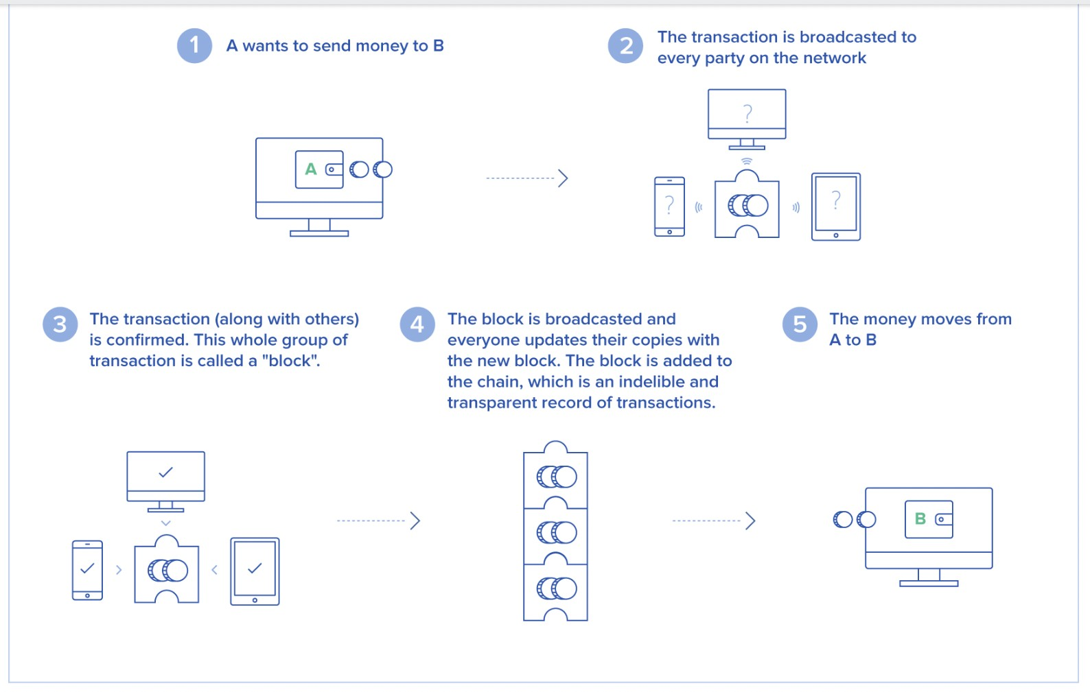

**Source:** Taken from Toptal

From a technological standpoint, the blockchain employs consensus techniques, and transactions are logged on several nodes rather than on a single server. A node is a computer that is linked to the blockchain network and automatically downloads a copy of the blockchain when it joins the network. All nodes must be in agreement for a transaction to be legitimate.

## Cryptocurrency Investing

As previously said, bitcoin has no intrinsic value, so what's the big deal? People invest in cryptocurrency for a variety of reasons. For starters, cryptocurrency prices include a speculative component that attracts speculators wanting to profit from market value fluctuations. For example, the price of Ether rose from $8 per unit in January 2017 to almost

$400 six months later as the Ether market grew more bullish, only to fall below $200 per unit in July owing to technical concerns.

In addition to sheer speculation, many people buy cryptocurrencies as a geopolitical hedge. The price of Bitcoin tends to rise during periods of political turmoil. In 2015 and 2016, as political and economic instability in Brazil intensified, Bitcoin exchange trading surged by 322 percent, while wallet use increased by 461 percent. Bitcoin prices rose in response to Brexit and Trump victories, and they continue to rise in tandem with Trump's political troubles.

## Traditional Currencies vs. Cryptocurrencies

Consider the following scenario: you wish to thank a colleague who bought you lunch by sending money to his or her account online. There are various possibilities for things to go wrong, including:

The financial institution may be experiencing a technical problem, such as its systems being down or the equipment not operating properly.

Your or a friend's account might have been hacked, resulting in a denial-of-service attack or identity theft.

Your or your friend's account transfer limitations may have been exceeded.

This is why bitcoin is the currency of the future. Consider a comparable transaction between two persons using the bitcoin app. A notice arrives informing the user that he or she is ready

to send bitcoins. If yes, processing begins: the system verifies the user's identification, determines whether the user has sufficient funds to complete the transaction, and so on.

After that, the

payment is transmitted and the funds are deposited into the receiver's account. This all happens in a couple of minutes.

The use of cryptocurrency, then, eliminates all of the difficulties associated with current banking: There are no transfer limitations, your accounts cannot be hacked, and there is no single point of failure. As previously said, there are over 1,600 cryptocurrencies accessible as of 2018. Some popular ones are Bitcoin & Ethereum. Every day, a new cryptocurrency is launched. Given how much growth they're now seeing, there's a high probability that there will be lots more to come.

## Importance of Cryptocurrency

Bitcoin is one of the most trustworthy and secure digital currencies accessible today. In an atmosphere where there are too many conmen and looters, we should just trade in the best possible forms. Cryptocurrencies offer us with certainty, making them an appealing investment option now and in the future.

Bitcoin tactics are another argument for their fast adoption and the significance of cryptocurrencies. When it comes to cryptocurrency, you shouldn't have to speak with a second team. This provides people with a sense of security and comfort. Because cryptocurrencies are digital currency, no third party is involved. You will do business regardless of the location.

## Cryptocurrency Market Dynamics

* + 1. **Driver: Transparency of distributed ledger technology**

Transparency issues develop when transactions occur without the awareness of stakeholders, particularly in Asian nations where fraudulent or undesirable transactions, such as the deduction of planned costs, are common. This might be due to human mistake, computer error, or data manipulation during the transaction process, and it could cost clients a lot of money. Furthermore, in most situations,

financial institutions refuse to assume responsibility. The public is dissatisfied with the present monetary system's lack of openness.

## Restraint: Uncertain regulatory status

The cryptocurrency market is unregulated at the moment. At the moment, the absence of laws and the ambiguity surrounding them are among the key reasons impeding cryptocurrency adoption. While financial regulatory agencies throughout the world attempt to develop universal rules for cryptocurrencies, regulatory adoption remains one of the most difficult obstacles. Because distributed ledger technology is still in its infancy, it creates a variety of challenges for regulators and politicians at both the national and international levels.

## Opportunity: Significant growth opportunities in emerging and developed markets

Emerging economies (such as India, China, and Brazil) and developed countries (such as the United States, Germany, and Japan) are likely to provide major growth prospects for cryptocurrency enterprises. For example, in 2020, Brazilian crypto firms signed a self-regulation rule aimed at legitimizing and increasing the acceptance of crypto assets in the country. The agreement was inked under the auspices of Abcripto, the country's cryptocurrency trade group. The agreement's goal is to create operating processes and compliance criteria that all members must follow.

## Challenge: Concerns regarding security, privacy, and control

Cryptocurrency has the potential to reform and revolutionize compliance-free peer-to-peer and remittance transactions; nevertheless, in order to profit from cryptocurrency, end users must overcome specific problems relating to security, privacy, and control. Because bitcoin transactions are recorded on the blockchain, a distributed public database, hackers have a huge attack surface to obtain access to crucial and sensitive information. If this public ledger is used to hold sensitive contract-related information or payment data, copying the file may make it simpler for hackers to gain access to it. If a key is compromised, it may be used to access the database in both a hub-and-spoke and a distributed model.

## Keys to Cryptocurrency Market Development

1. **Consumers and Merchants**

Cryptocurrencies give users with cheaper and faster peer-to-peer payment options than traditional money services firms, without the need to submit personal information. While cryptocurrencies continue to gain acceptability as a payment alternative, price volatility and the chance for speculative investments drive people to trade cryptocurrency rather than use it to purchase products and services.

## Tech Developers

Many competent tech professionals have devoted their efforts to cryptocurrency mining, while others have devoted their efforts to more entrepreneurial endeavors such as building exchanges, wallet services, and alternative cryptocurrencies. In our opinion, the cryptocurrency market has just recently begun to attract talent with the depth, breadth, and market focus required to propel the sector forward. However, for the market to obtain general recognition, consumers and organizations must regard cryptocurrencies as a user-friendly alternative to everyday transactions. In addition, the industry must create cybersecurity technologies and standards.

## Investors

Investors tend to be optimistic about the potential presented by cryptocurrency and encryption. The underlying technology's "inherent value," as stated above, provides these investors cause to be optimistic. As a result, several of the more established cryptocurrency startups have just lately gained institutional investors and Wall Street attention.

## Financial Institutions

Banks have always matched people who have money with others who need it. However, in recent years, this intermediary role has been eroded, and disintermediation in the banking sector has progressed swiftly. This has occurred as a result of the expansion of Internet banking, increased consumer use of alternative payment methods such as Amazon gift cards, Apple Pay, and Google Wallet, and advancements in mobile payments.

## Regulators

When it comes to the categorization, handling, and legality of cryptocurrencies, government perspectives vary throughout the world. Regulations change at various rates in different parts of the world.

## The Evolution of Cryptocurrency Market

After months of steady expansion, the cryptocurrency industry breached the $100 billion market value threshold in June 2017. Despite its growing importance in the financial world, most studies have focused primarily on the behavior of one (Bitcoin) or a few cryptocurrencies, thus a complete examination of the entire system is still absent. We look at the full market's history and analyze the behavior of 1469 cryptocurrencies launched between April 2013 and May 2017. Despite the fact that new cryptocurrencies arise and depart on a regular basis, and their market value grows exponentially, the market's statistical features have remained steady for years. The amount of active cryptocurrencies, market share distribution, and cryptocurrency turnover are all examples. Despite its simplicity and the assumption of no selection advantage of one cryptocurrency over another, the so-called neutral model of evolution can recreate a number of crucial empirical results by using an ecological approach.

In recent years, cryptocurrency, particularly Bitcoin, has proven its worth, with 14 million Bitcoins currently in circulation. Most of the present market capitalisation has been driven by investors speculating on the future prospects of this new technology, and this is expected to continue until a certain level of price stability and market acceptability is attained. Those that invest in cryptocurrencies appear to be depending on a supposed "inherent value" of cryptocurrency in addition to the proclaimed price. This encompasses the technology and network as a whole, as well as the cryptographic code's integrity and the network's decentralized nature.

In addition to the existing payment system, the blockchain public ledger technology (which underpins cryptocurrencies) has the potential to disrupt a wide range of transactions. These include stocks, bonds, and other financial assets for which digital records are kept and for which a trusted third party is now required to provide transaction verification.

The cryptocurrency market will evolve at the speed determined by the leading players, with expected periods of rapid growth of legitimacy from one or more of them. " Each of the five essential market participants, merchants and consumers, tech developers, investors, financial institutions, and regulators will play a role in the industry's next phase of evolution toward general acceptance and sustained expansion.

Cryptocurrencies are being utilized as a medium of exchange for everyday payments, which is why Bitcoin was created, as well as for speculation. Other applications include payment rail for low-cost cross-border money transfers and non-monetary applications such as time stamping. The self-organization of multiple usages both inside a single cryptocurrency and as a distinguishing feature across cryptocurrencies distinguishes the cryptocurrency market, making its price particularly volatile.

Cryptocurrencies represent the start of a new era of technology-driven markets that has the ability to uplift traditional market tactics, long-standing company practices, and established regulatory viewpoints, all to the advantage of consumers and macroeconomic efficiency. Cryptocurrencies have the potential to provide consumers with unprecedented access to a global payment system that can be used anywhere, at any time, and where participation is limited only by one's ability to use technology rather than having a credit history or a bank account.

# Chapter - 4 Company Profile



## Bitcoin

Satoshi Nakamoto, a pseudonymous individual or group, developed Bitcoin in a white paper published in 2008. Bitcoin is a digital currency that enables for safe peer-to-peer transactions via the internet, and it's an appealingly simple notion.

Unlike systems like Venmo and PayPal, which rely on the old banking system for authorization to transfer money and on existing debit/credit accounts, bitcoin is decentralized: anybody, anywhere in the world, may send bitcoin to anyone else.

Every Bitcoin transaction is recorded on the blockchain, which is analogous to a bank's ledger or log of clients' monies entering and exiting the bank. In simple terms, it's a log of every bitcoin transaction ever made.

The Bitcoin blockchain, unlike a bank's ledger, is dispersed over the whole network. It is not under the authority of any corporation, government, or third party, and anybody can join it.

Only 21 million bitcoins will ever exist. This is a form of digital currency that cannot be manipulated or inflated in any manner.

You don't have to buy one full bitcoin; if that's all you want or need, you may buy a portion of one.

## Bitcoin Basics

Thousands of other cryptocurrencies have been developed since Bitcoin's inception, but bitcoin (abbreviated as BTC) remains the most valuable in terms of market capitalization and trading volume.

## Figure - 4.1

Bitcoin functioning

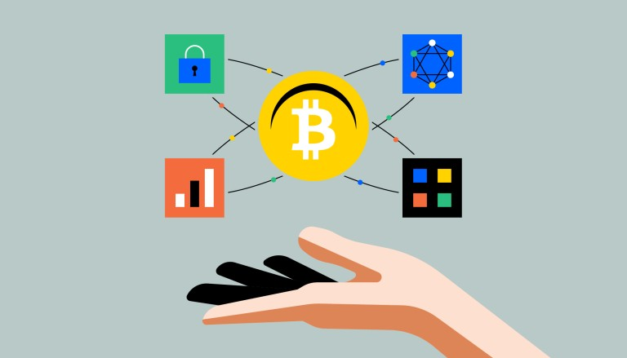

**Source:** Taken from the Coinbase

Bitcoin may be used for a variety of purposes, depending on your objectives.

* as an investment vehicle
* as a store of value comparable to gold
* as a means of transferring money over the world
* or simply as a means of investigating a nascent technology
  + Bitcoin is a digital money that was created on the internet. Bitcoin, unlike government-issued currencies like the dollar or euro, permits internet transfers without

the use of an intermediary like a bank or payment processor. The absence of those gatekeepers opens up a slew of new possibilities, including the ability for money to travel more swiftly and inexpensively over the global internet, as well as allowing individuals to have complete ownership over their own assets.

* + It is legal to use, retain, and exchange Bitcoin, and it may be used for anything from travel to charity donations. Businesses like Microsoft and Expedia accept it as payment.
  + Is bitcoin a form of currency? It has served as a medium of trade, a store of value, and a unit of account, all of which are characteristics of money. In the meantime, it is only available digitally; there is no physical edition.

## Creator of Bitcoin

It's easier to understand how bitcoin works if you start from the beginning. The subject of who invented bitcoin is intriguing since, despite extensive investigation by journalists and members of the crypto community, its creator remains unknown a decade later.

* + - The concepts of Bitcoin were initially disclosed online in late 2008 by a person or group known as Satoshi Nakamoto in a white paper.
    - The bitcoin private key and the blockchain ledger are two interwoven ideas created by Nakamoto. You control bitcoin using a private key, which is a string of randomized numbers and letters that unlocks a virtual vault storing your purchase. Each private key is recorded on the blockchain, a distributed ledger.

## Bitcoin Functions

Bitcoin is not controlled by an individual or a firm, unlike credit card networks like Visa and payment processors like Paypal. Bitcoin is the world's first truly open payment network, accessible to anybody with an internet connection. Bitcoin was created to be used online and does not rely on banks or private corporations to complete transactions.

The blockchain is one of the most significant aspects of Bitcoin, as it monitors who owns what, similar to how a bank manages assets. The Bitcoin blockchain differs from a bank's ledger in that it is decentralized, which means that anybody can see it and no single institution has control over it.

## Bitcoin Accumulation

1. Each user who joins the bitcoin network is given a public key, which is a lengthy string of letters and numbers that functions similarly to an email address, as well as a private key, which functions similarly to a password.
2. You obtain a public key when you buy bitcoin—or send/receive it—which you may think of as a key that opens a virtual vault and enables you access to your funds.
3. Anyone may transfer bitcoin to you using your public key, but only the private key holder has access to the bitcoin once it's been delivered to the "virtual wallet."
4. Bitcoin may be stored in a variety of ways, both online and offline. A virtual wallet is the most straightforward approach.

## Figure - 4.2

Transaction volume of Bitcoin

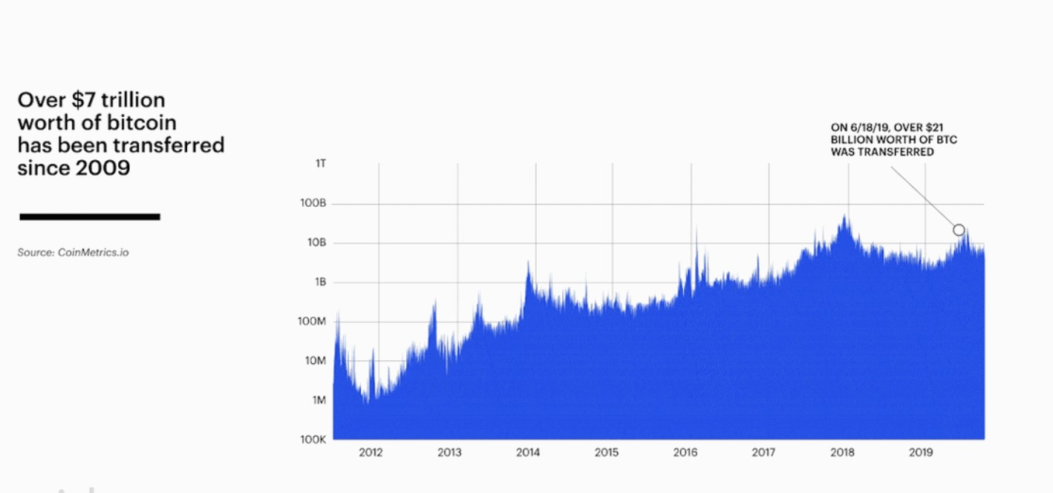

## Origin of Bitcoin

Bitcoin is mined' by a massive, decentralized (also known as 'peer-to-peer') network of computers that are continually checking and safeguarding the blockchain's correctness. Every single bitcoin transaction is recorded on that ledger, with fresh information being gathered in "blocks'' that are added to previous blocks on a regular basis.



## Ethereum

After Bitcoin, Ethereum is the second-largest cryptocurrency by market capitalization. It's also a decentralized computing platform capable of running a broad range of apps, including the full DeFi world.

After Bitcoin, Ethereum is the second-largest cryptocurrency in terms of market capitalization. But, unlike Bitcoin, it was never intended to be used as a kind of electronic money. Instead, Ethereum's creators set out to create a new type of global, decentralized computing platform that extends the security and openness of blockchains to a wide range of applications.

The Ethereum blockchain is currently powering everything from financial tools to games to complicated databases. And only developers' ideas may restrict its future possibilities. "Ethereum can be used to codify, decentralize, secure, and exchange just about anything," according to the Ethereum Foundation, a charitable organization.

* + - Ethereum has grown in popularity as an investment instrument and a means of storing money (and can be used, like Bitcoin, to send or receive value without an intermediary).
    - The Ethereum blockchain enables developers to create and run a wide range of apps, from games to advanced databases to complicated decentralized financial instruments, all without the need for a bank or other intermediary.
    - Smart contracts are used to create Ethereum-based apps. Smart contracts, like traditional paper contracts, define the conditions of a deal between two parties. Smart contracts, unlike traditional contracts, automatically execute when the requirements are satisfied, without requiring either party to know who is on the other side of the agreement – or any type of verification.
    - Ethereum, like Bitcoin, is an open source project run by a group of people rather than a single person. Anyone with access to the internet may run an Ethereum node and interact with the Ethereum network.
    - Smart contracts running on Ethereum's decentralized blockchain allow developers to build complex applications that should run exactly as programmed without downtime, censorship, fraud, or third-party interference, much like Bitcoin's decentralized blockchain allows any two strangers, anywhere in the world, to send or receive money without a bank in the middle.

## Ethereum Security

The Ethereum blockchain is now securing ETH in the same way that Bitcoin's blockchain is securing Bitcoin. Every transaction is verified and secured by a massive amount of processing power given by all of the machines on the network, making it almost difficult for any third party to intervene.

## Figure - 4.3

Ethereum security

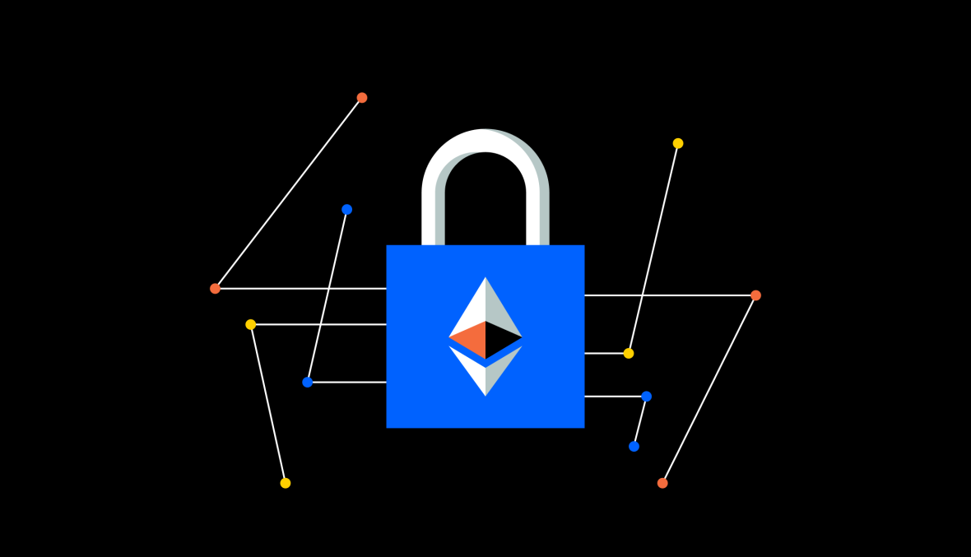

**Source:** Taken from the Coinbase

The underlying concepts of cryptocurrencies contribute to their security: the systems are permissionless, and the main software is open-source, allowing a large number of computer scientists and cryptographers to analyze all elements of the networks' security.

Apps that operate on the Ethereum blockchain, on the other hand, are only as safe as their creators make them. For instance, code might occasionally have errors that result in money being lost. While everyone can see their source code, the user bases of individual apps are significantly smaller than Ethereum's overall, therefore there are fewer eyes on them. Any decentralized app you want to utilize should be thoroughly researched.

## Ethereum Functions

You may have heard that the Bitcoin blockchain works similarly to a bank's ledger or a checkbook. It's a running count of every transaction conducted on the network from its inception, with all of the machines on the network contributing their CPU power to ensure the total is accurate and safe.

The Ethereum blockchain, on the other hand, is more like a computer: while it performs the same functions as the Bitcoin blockchain in terms of documenting and safeguarding transactions, it is far more adaptable. The Ethereum blockchain may be used to create a wide range of tools, from logistics management software to games to the complete universe of DeFi apps (which span lending, borrowing, trading, and more).

* + - To do this, Ethereum employs a 'virtual machine,' which functions as a massive, global computer composed of many individual computers running the Ethereum software. Participants must spend both hardware and power to keep all of those machines working. The network pays for these expenses with Ether, a Bitcoin-like cryptocurrency (or, more commonly, ETH).
    - The entire system is kept functioning with ETH. You engage with the Ethereum network by paying it with ETH to have smart contracts executed. As a result, ETH fees are referred to as "gas."
    - The cost of gas varies according to how busy the network is. In December 2020, Ethereum 2.0, a new version of the Ethereum blockchain that attempts to improve efficiency, became live.

## Ethereum History

* + - Vitalik Buterin, a 19-year-old computer programmer (and cofounder of Bitcoin Magazine), publishes a whitepaper suggesting a highly flexible blockchain that could handle nearly any type of transaction.Brian Armstrong, our CEO and co-founder, recently talked with Vitalik Buterin, the Ethereum developer, about ETH2 and the crypto economy's scalability (2013).
    - With the sale of $18 million in pre-launch tokens, the Toronto-based adolescent, together with a team of co-founders including Gavin Wood, crowdfunds the development of the Ethereum protocol (2014).
    - In July, the Ethereum blockchain's first public version will be released. On the Ethereum blockchain, smart contract capability is starting to roll out (2015).
    - By exploiting a software weakness, hackers stole about $50 million from the DAO (short for Decentralized Autonomous Organization), a smart-contract-powered venture fund. Ethereum's community chooses to change the protocol in a way that will recover the lost funds in a controversial vote. As a result, the Ethereum blockchain splits into two independent blockchains (by a hard fork), each with its own active community: Ethereum and Ethereum Classic (2016).
    - The ERC-20 standard is established, making it easier for developers to construct apps that are interoperable. ERC-20 is a standard for creating assets (or tokens) on

the Ethereum network. The first widely successful Ethereum-based application is CryptoKitties, a game in which users acquire and sell digital kittens. It becomes a true obsession, with rare digital cats fetching upwards of $200,000 at their height. The Ethereum Enterprise Alliance is a non-profit organization dedicated to the development of practical applications for smart contract technology. JP Morgan, Samsung, Microsoft, and Mastercard are among the members. MakerDAO, the Ethereum blockchain's first Decentralized Finance (or DeFi) protocol, has launched. Maker also announces DAI, the first ETH-based stablecoin, and ETH reaches a new high of $100 USD (2017).

* + - With the launch of lending protocol Compound and decentralized exchange Uniswap, DeFi gains traction in its goal to disrupt the financial services industry by making transactions faster, cheaper, and more secure. The USDC stablecoin is now available for use. It achieved $1 billion in issued coins in its first year, thanks to the CENTER Consortium, a cooperation between Coinbase and Circle. In January, ETH broke the $1,000 USD barrier for the first time, before plummeting below $100 (2018).
    - The transition to Ethereum 2.0 will begin in December. The move from Ethereum

1.0 to Ethereum 2.0 is expected to take around two years. Proof of Stake is introduced as part of Ethereum 2.0's initial phase. Proof of Work remains the consensus technique in ETH 1.0 (2020).

* + - In February, ETH hit an all-time high of $1,700 (2021).

## Smart contracts 101

Nick Szabo, a computer scientist and lawyer, initially advocated smart contracts in the 1990s. A smart contract, according to Szabo, is similar to a vending machine. Consider a machine that sells quarter soda cans. If you put a $1 in the machine and choose a beverage, the system is programmed to either give you your drink and 75 cents in change, or encourage you to make another option or get your dollar back if your pick is sold out. This is a simple smart contract example. Smart contracts can automate nearly any type of trade, much like a Coke machine can automate a sale without the need for a human middleman.

## Bitcoin vs. Ethereum

Bitcoin and Ethereum are the two most extensively used blockchain applications currently available. While many people believe they are competitors, this is not the case. Ethereum is a digital world, while Bitcoin is digital gold. Blockchain technology is used by both cryptocurrencies to establish a value layer for the internet, although Bitcoin's technology is confined to payments and scarcity. Ethereum advances blockchain technology by incorporating a computer into the value layer, replacing traditional financial processes like lending and trade with code.

Both systems are powered and protected by a decentralized network of individuals (miners) all over the world who are compensated for contributing to the network's security. The key premise of blockchain technology is decentralization, which distinguishes Bitcoin from the digital dollar, which is centralized and controlled by the US government. Satoshi Nakamoto created bitcoin to decentralize control of money when centralized organizations failed the globe in 2008. Ethereum was inspired by Bitcoin, but with the addition of smart contracts, it improved upon Bitcoin.

# Chapter - 5 Conceptual Framework

## Introduction

Cryptocurrencies provide incredible prospects for innovation and progress, but they are also ideally adapted to promote illegal activity. The legislative structure proposed here is designed to assist (or at the very least not hinder) the inventive potential of cryptocurrencies. At the same time, it tries to eliminate the illegal use of cryptocurrencies. To achieve these goals, this is a regulatory framework that imposes penalties on properties of cryptocurrencies that make them particularly helpful for criminal conduct (such as anonymity), but not on traits that are at the heart of cryptocurrencies' generative potential (in particular, the decentralization of value-transfer processes). It demonstrates how regulatory instruments may be developed in this way, using a basic utility model of criminal conduct as a baseline. An example of such a regulatory device is an opt-in anonymity tax on bitcoin transactions involving at least one non-anonymous participant.

A cryptocurrency is a digital currency that is represented by an encrypted data string. A peer-to-peer network known as a blockchain monitors and organizes it, as well as serving as a secure database of transactions such as buying, selling, and transferring.

The creation and widespread usage of blockchain technology, which exploits the potential of current technologies to benefit global commerce, is a feature of today's world. This is the next step in globalization, and it entails decentralizing authority and decreasing the influence of time and distance on global transactions. BitCoin, the first and most well-known cryptocurrency, is at the forefront of these new developments. With its rising market value, this is now the only truly popular cryptocurrency that has attracted even the most skeptics among its investors. Bitcoin, as well as the tens of thousands of other cryptocurrencies, are the voices of new trends, mostly in business, but also in technology.

## Characteristics of Cryptocurrencies

With the publication of a whitepaper titled "Bitcoin: A Peer-to-Peer Electronic Cash System," an anonymous individual or group of individuals named Satoshi Nakamoto invented the first cryptocurrency, Bitcoin, in the midst of the Financial Crisis of 2008, very few people noticed this game-changing innovation of currency at the time.

Cryptography and blockchain technology have advanced to the point that bitcoin is now a viable alternative means of trade. Since its inception in 2009, the presence of cryptocurrency

has grown in popularity throughout the world. It has gotten a lot of attention because of its distinct traits.

To truly comprehend the cryptocurrency revolution, it is necessary to first comprehend the underlying characteristics of cryptocurrencies and blockchain technology that make them so innovative and game-changing.

Bitcoin is a cryptographically secure money that was designed to be used for payments worldwide, much like cash. It's a decentralized digital currency that may be exchanged from user to user on a peer-to-peer network as a means of exchange of value without the involvement of middlemen or a central regulating body.

Cryptography is used to verify and safeguard transactions in cryptocurrencies. Bitcoin is the first cryptocurrency to be created with the goal of creating a decentralized and autonomous electronic payment system. To tackle the problem of "double spending" (digital assets may easily be duplicated and re-used) and to validate and execute transactions, Bitcoin employs encryption, mathematical proofs (proof of work), and economic incentives (mining).

## Here are the 4 key characteristics of cryptocurrency:

1. **Decentralized**

The financial system is controlled by central authorities and banks in conventional fiat currencies. These transactions, however, may be conducted and confirmed by a distributed and open network that is controlled by no one with Bitcoin and other cryptocurrencies. In every case, the central authority becomes the key flaw that leads to the currency's death.

The majority of cryptocurrencies are decentralized and run on dispersed networks of computers called nodes that are located all over the world. Network nodes use cryptography to verify transactions, which are then stored in a public distributed ledger called a blockchain. The transaction is replicated by every node throughout the peer-to-peer network, reaching a high majority of nodes in a matter of seconds.

## Immutable and irreversible

Immutability in blockchain and cryptocurrency should be based on three principles:

* + Rewriting history should be extremely unlikely or difficult.
  + Anyone other than the owner of a private key should be unable to move funds.
  + The blockchain keeps track of all transactions (to guarantee the above 2 principles)

Because bitcoin is irreversible and unchangeable, it is impossible for anybody other than the owner of the relevant private key to transfer their digital assets, and transactions cannot be modified once they have been recorded on the blockchain.

Because the characteristics of centralization and trust have been eliminated from cryptocurrencies, there is no longer a third party to whom we can entrust these tasks. As a result, transaction records are made available to the public and are not subject to alteration (immutable).

Although changing the transaction ledger is not impossible, cryptographic security makes it exceedingly difficult. It necessitates compromising the entire bitcoin network.

## Anonymous

Users are not required to identify themselves while transacting with cryptocurrencies since there is no requirement for a central authority. When a transaction request is filed, the decentralized network examines and verifies the transaction before recording it on the blockchain. To authenticate transactions, cryptocurrencies like Bitcoin employ a private key and public key scheme. Users may create anonymous digital identities and digital wallets to transact on the decentralized system while yet having their transactions safely authenticated.

## Scarcity and limited supply

The quantity of fiat currency is limitless since central banks can issue and/or print as much as they wish. As part of their economic plans, central banks frequently alter the value of a country's currency. Because fiat currencies are inherently inflationary, their value will depreciate over time.

Most cryptocurrencies, on the other hand, have a restricted and predetermined supply that is built into the underlying algorithm when the coin is formed.

Without the permission of the majority, no person or group may impact the supply of money or exercise considerable influence over it using cryptocurrencies. Maximum token supply limitations or a limitless supply with predefined output are common features of leading cryptocurrencies.

Many popular cryptocurrencies, like Bitcoin, Litecoin, and Dash, have a finite supply, making them naturally deflationary. Any rise in the cryptocurrency's demand or acceptance will result in an increase in its price.

The main variables that are influencing investors’ decision-making process in cryptocurrency investment in India are:

Financial literacy Perceived risk

Expectation of performance Social influence

According to the outcome of my analysis, 25 percent of people in India are influenced by cryptocurrencies' expected performance (the highest), 21% by social factors, 11% by perceived risk, and 9% by its really high price (the least).

## Figure - 5.1

Intentions to use cryptocurrencies

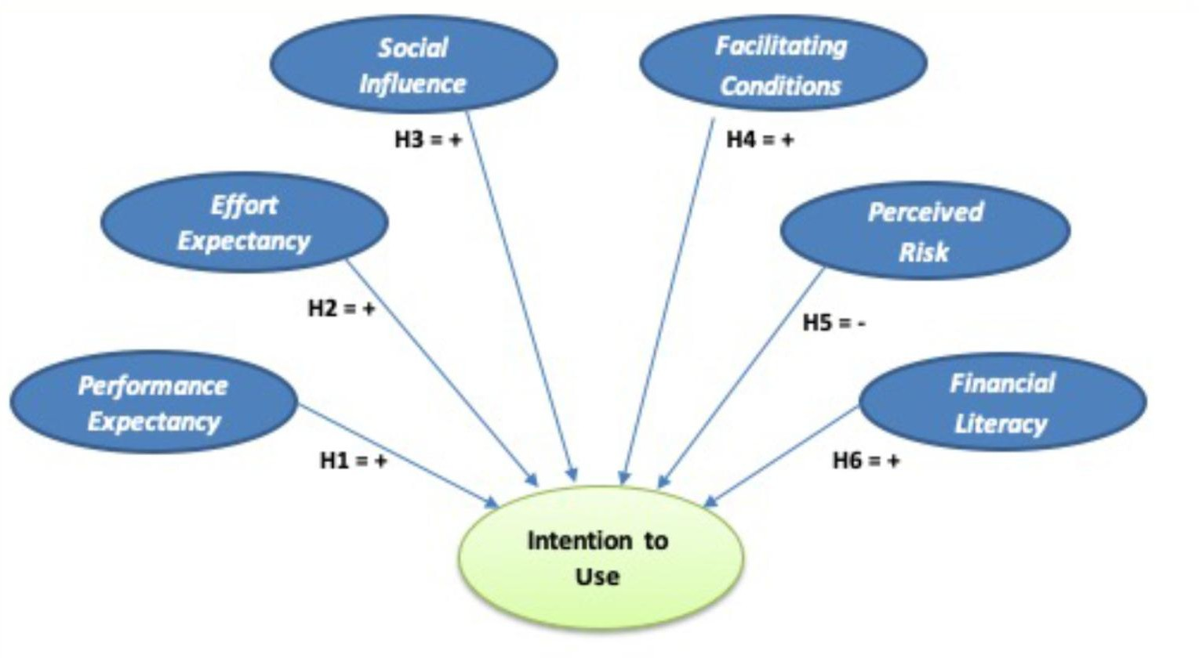

**Source:** Taken from the Frontiersin

## Advantages

1. **Inflation protection**

Inflation has caused the value of several currencies to depreciate over time. Almost every cryptocurrency is introduced with a predetermined quantity at the moment of its inception. The number of every currency is specified in the source code; for example, there are only 21 million

Bitcoins available in the globe. As a result, as demand rises, its value rises as well, keeping pace with the market and, in the long term, preventing inflation.

## Self-managed and governed

Any currency's governance and upkeep are critical to its growth. Developers/miners are rewarded for storing bitcoin transactions on their hardware by receiving the transaction fee. Because the miners are compensated for their work, they maintain transaction records accurate and up-to-date, ensuring the cryptocurrency's integrity and decentralizing the records.

## Protected and private

Cryptocurrencies' privacy and security have long been a key worry. The blockchain ledger is made up of a series of difficult-to-solve mathematical riddles. As a result, bitcoin transactions are more secure than regular electronic transactions. Cryptocurrencies employ pseudonyms that are unrelated to any user, account, or stored data that might be attributed to a user for improved security and privacy.

## Decentralized

One of the key advantages of cryptocurrencies is that it is mostly decentralized. Many cryptocurrencies are controlled by the developers who use them and those who own a considerable quantity of the coin, or by a company that develops them before they are launched into the market. Unlike fiat currencies, which are controlled by the government, decentralization helps keep the currency monopoly free and in check so that no single entity can dictate the flow and value of the coin. This, in turn, keeps it stable and safe.

## Cost-effective means of transaction

Sending money across borders is one of the most common uses of cryptocurrencies. The transaction fees paid by a user are decreased to a minimal or nil amount with the help of

bitcoin. It achieves it by removing the requirement for third-party verification, such as VISA or PayPal. This eliminates the need for any further transaction costs.

## A quick method of transferring payments

Cryptocurrencies have always maintained their position as the best option for transactions. Cryptocurrency transactions, whether international or domestic, are lightning quick. This is due to the fact that the verification takes extremely little time to complete because there are so few hurdles to overcome.

## Disadvantages

1. **Can be used for illicit activities**

Due to the great secrecy and security of cryptocurrency transactions, it's difficult for the authorities to trace down or monitor any user by their wallet address. Bitcoin has already been used as a means of transferring money in a variety of criminal transactions, including the purchase of narcotics on the dark web. Some people utilize cryptocurrency to mask the origins of their illegally obtained money by converting it through a trustworthy middleman.

## Financial losses might result from data loss

The designers aimed to make source code that was essentially untraceable, powerful hacker defenses, and impenetrable authentication mechanisms. Putting money in cryptocurrency, rather than actual cash or bank vaults, would be safer. However, if a user loses their wallet's private key, there is no way to recover it. The wallet, as well as the quantity of coins within, will be kept secure. The user will suffer a financial loss as a result of this.

## Although decentralized, some entity is still in charge of it

Cryptocurrencies are well-known for their decentralized nature. However, the founders and some organizations still control the flow and amount of various currencies on the market. These investors have the ability to influence the coin's price in order to achieve big price fluctuations. Even heavily traded currencies, such as Bitcoin, which rose in value many times in 2017, are vulnerable to similar tricks.

1. **There are several coins that aren't accessible in any other fiat currency** Some cryptocurrencies can only be bought and sold in a limited number of fiat currencies. This compels the user to first convert these currencies into one of the major currencies, such

as Bitcoin or Ethereum, and then into their preferred currency via other exchanges. Only a few coins are affected. This adds extra transaction costs to the process, costing you money you don't need.

## Adverse Effects of mining on the environment

Cryptocurrency mining necessitates a lot of computer power and electricity, making it a very energy-intensive process. Bitcoin is the main perpetrator in this. Bitcoin mining necessitates powerful processors and a lot of energy. It's impossible to do with a regular PC. Bitcoin miners

are concentrated in nations where coal is used to generate energy, such as China. China's carbon footprint has risen dramatically as a result of this.

## Susceptible to hacks

Although cryptocurrencies are extremely safe, exchanges are not. Most exchanges save user wallet info in order to correctly operate their user ID. Hackers might steal this information, allowing them access to a large number of accounts.

These hackers can quickly move cash from such accounts once they have gained access. Some exchanges, like Bitfinex and Mt Gox, have been hacked in recent years, and Bitcoin worth hundreds to millions of dollars has been stolen. Although most exchanges are now quite safe, another hack is always a possibility.

# Chapter - 6 Data Analysis

## Customer Responses Analysis

**Table - 6.1**

|  |  |  |
| --- | --- | --- |
| **Gender** | **No of respondents** | **Percentage** |
| Male | 39 | 78% |
| Female | 11 | 22% |

## Figure - 6.1

Gender

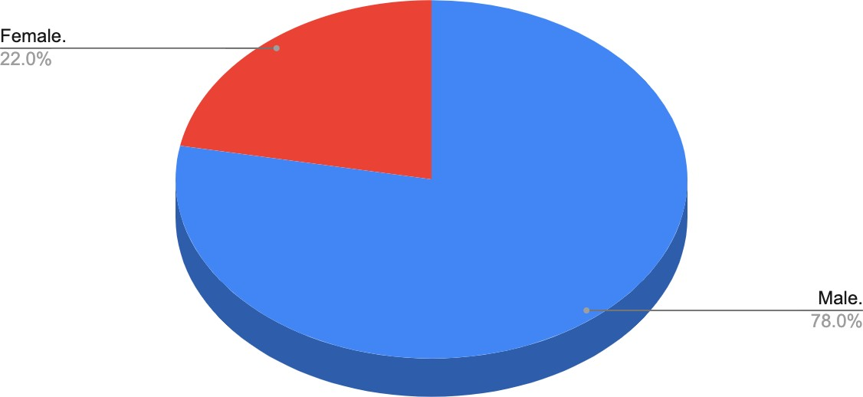

**Source:** Computed by the researcher

The above chart depicts the gender categorization of respondents. There are 39 male respondents and 11 female respondents among the 50 respondents.

## Table - 6.2

|  |  |  |
| --- | --- | --- |
| **Age** | **No of respondents** | **Percentage** |
| 20 & under | 19 | 38% |
| 21 - 29 | 27 | 54% |
| 30 - 31 | 4 | 8% |

**Figure - 6.2**

Age

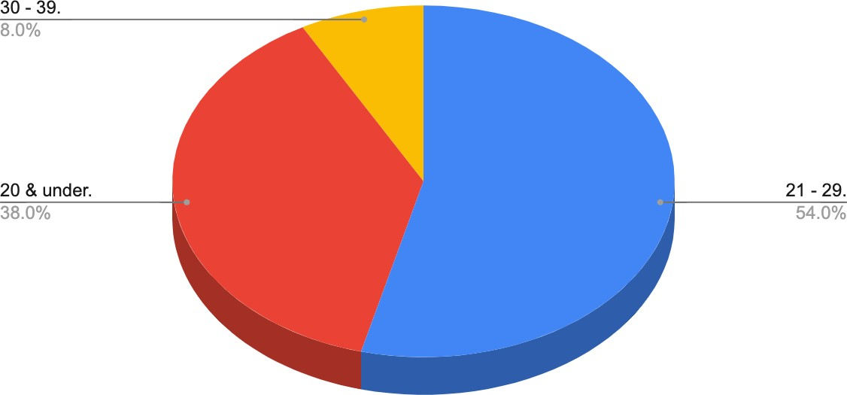

**Source:** Computed by the researcher

The above chart depicts the age categorization of respondents. There are 19 respondents of age 20 & under, 27 respondents of age 21-29 and 4 respondents of age 30-39 among the 50 respondents.

## Figure - 6.3

Occupation

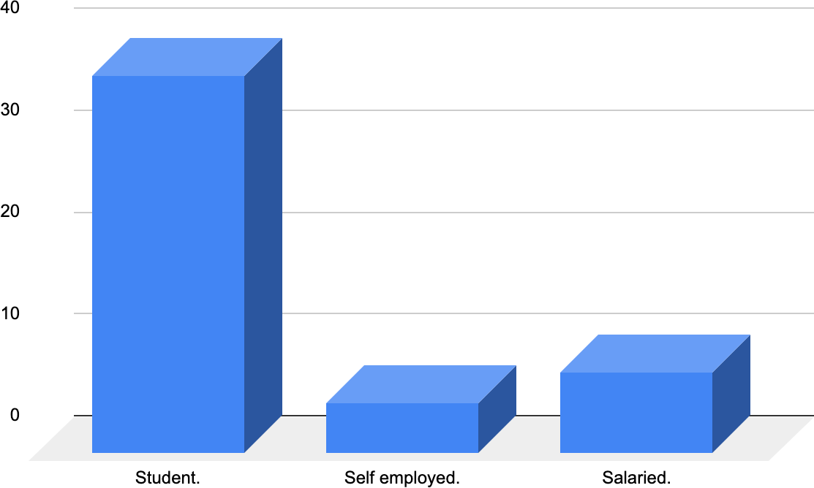

**Source:** Computed by the researcher

The above chart depicts the occupation categorization of respondents. Among the 50 respondents 39 respondents are students, 8 respondents are salaried and 5 respondents are self employed.

## Figure - 6.4

Annual personal income range

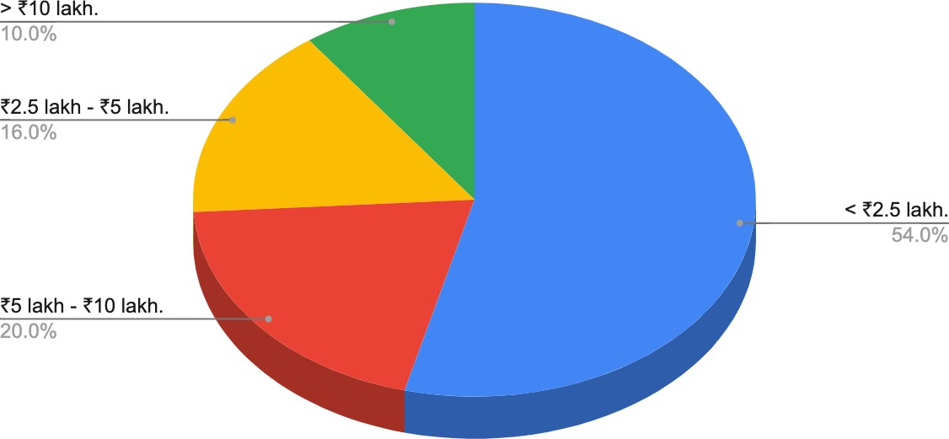

**Source:** Computed by the researcher

The figure below depicts the respondents' yearly personal income range. Among the 50 respondents, 54 percent have an income range of less than 2.5 lakhs (the highest) and 10 percent have an income range of more than 10 lakhs (the lowest).

## Figure - 6.5

Respondent’s awareness about Cryptocurrencies

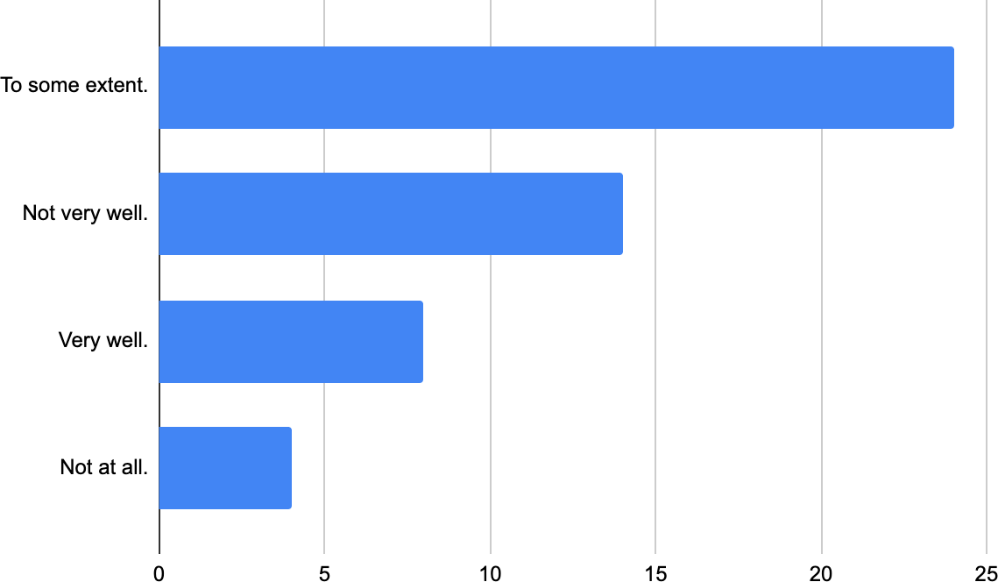

**Source:** Computed by the researcher

The graph above depicts how well respondents say they know about cryptocurrency. Out of 50 respondents, 24 feel they are aware of cryptocurrencies to some level, i.e. 48% of them believe they are aware of cryptocurrencies to some extent.

## Figure - 6.6

Ownership held by people in Cryptocurrencies

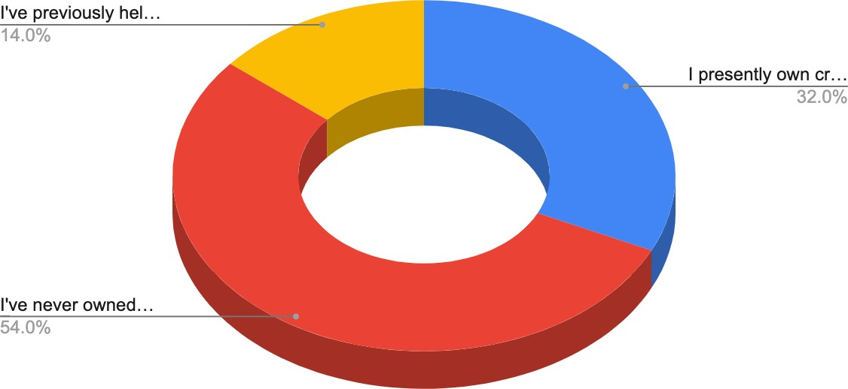

**Source:** Computed by the researcher

According to the chart, just 32% of respondents currently possess cryptocurrencies, 14% previously held cryptocurrencies, and 54% have never owned cryptocurrencies.

## Figure - 6.7

Medium of exposure

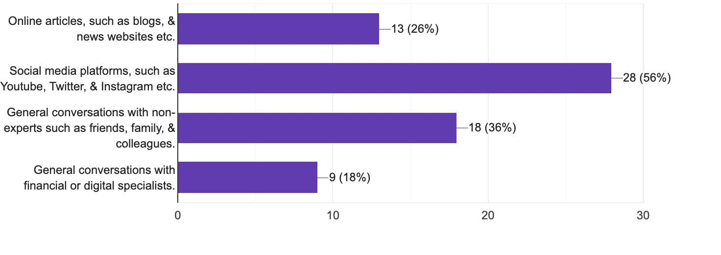

**Source:** Computed by the researcher

The graph above represents the respondents' first encounter with cryptocurrency. The majority of them get the most exposure via social media sites like YouTube, Twitter, and Instagram (56%) and the least exposure from general communication with non-experts like friends, family, and coworkers (18%).

## Figure - 6.8

Reaction of people towards financial advice

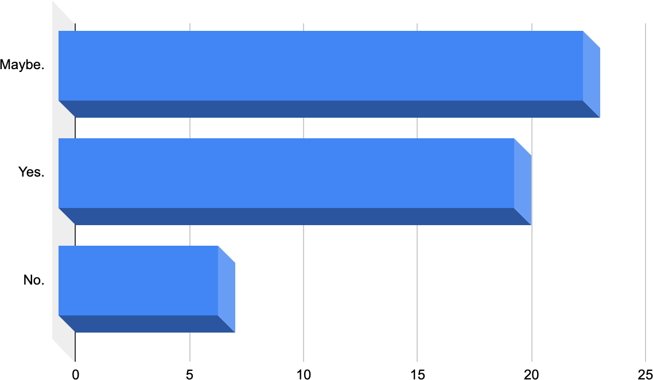

**Source:** Computed by the researcher

The graph above depicts whether respondents follow the advice of others when investing in cryptocurrency. When it comes to cryptocurrency investments, 20 of the 50 respondents follow the advice of others, while 7 do not.

## Figure - 6.9

Reason for investing in Cryptocurrencies

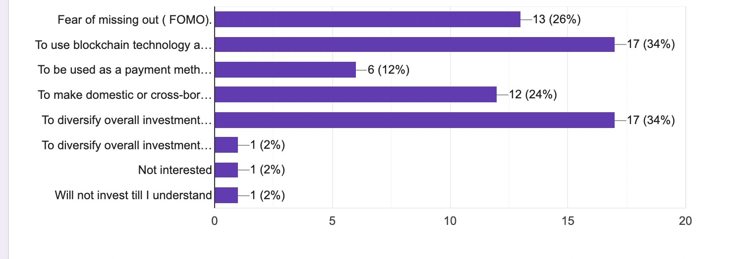

**Source:** Computed by the researcher

The graph above displays the reasons why respondents choose to invest in cryptocurrency. where blockchain technology may be used to promote decentralized finance & Using blockchain technology to promote decentralized finance has a 17 percent share, while using it as a payment mechanism for online transactions has a 6 percent share.

## Figure - 6.10

Impact of dips on people

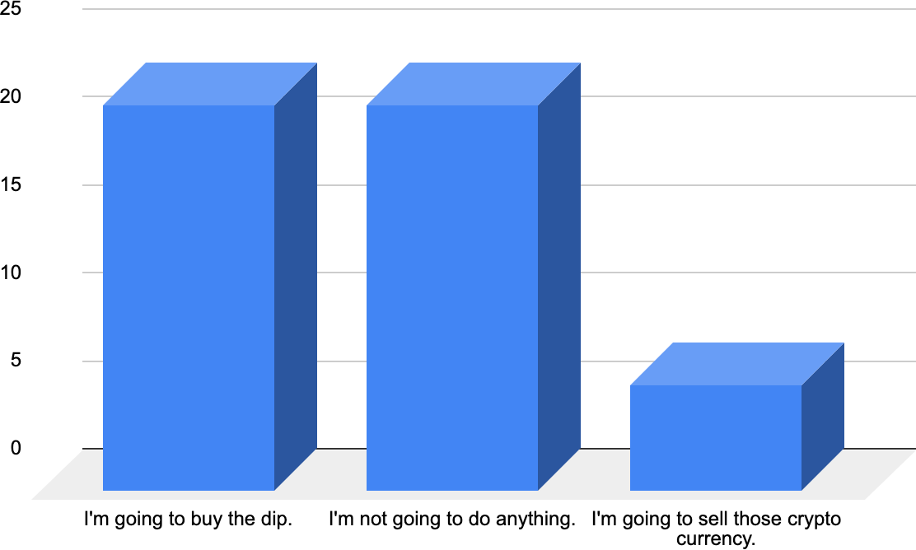

**Source:** Computed by the researcher

The graph above depicts what respondents would do if the price of cryptocurrency assets fell while they were being purchased or if they wanted to acquire them in the future. They are going to purchase the dip and do nothing else; each holds 44%. They intend to sell those cryptocurrencies holding 12%.

## Figure - 6.11

Loss bearing capacity of people

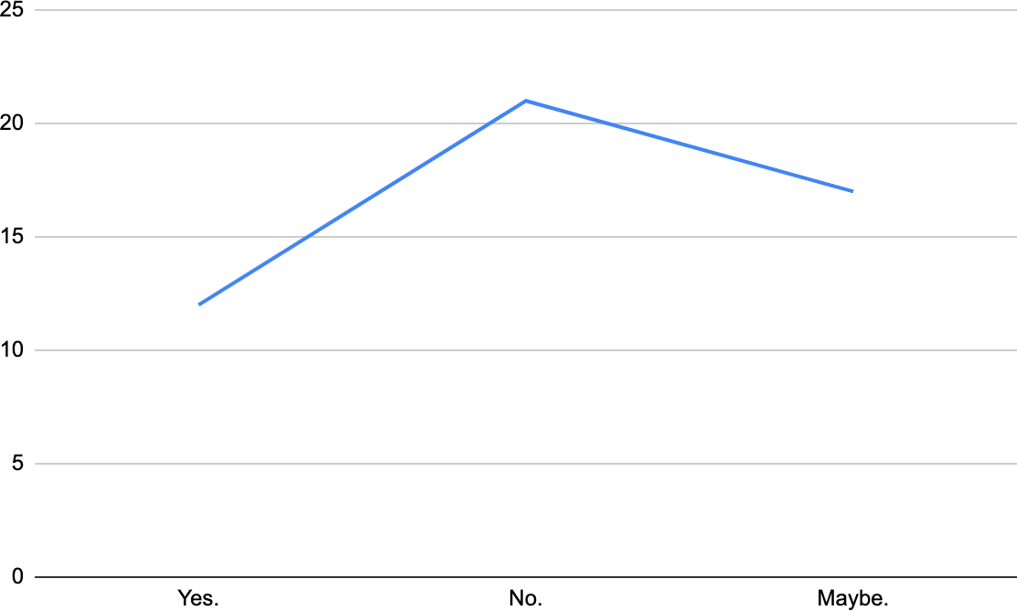

**Source:** Computed by the researcher

The graph above illustrates how many of them can afford to lose all of their cryptocurrency investments or if they invest in the future. 12 of them answer yes, while 21 of them say no.

## Figure - 6.12

Willingness to buy

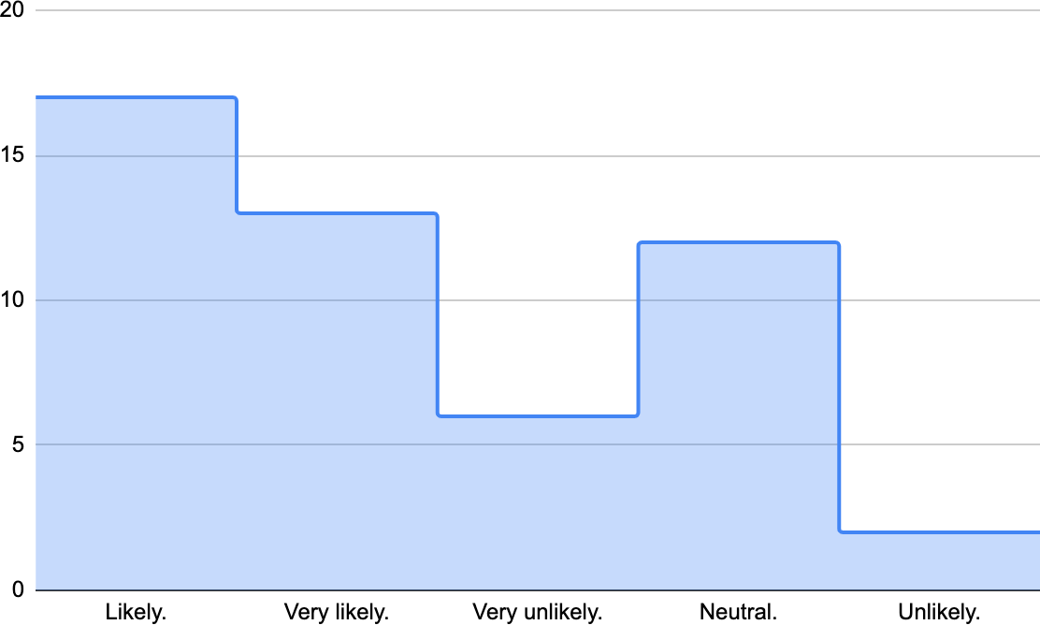

**Source:** Computed by the researcher

The graph above depicts the likelihood of respondents purchasing cryptocurrency assets while considering future investments. where 17 are likely to purchase cryptocurrencies (the highest) and 6 are unlikely to purchase cryptocurrencies (the least).

## Figure - 6.13

Willingness to buy diversified portfolio

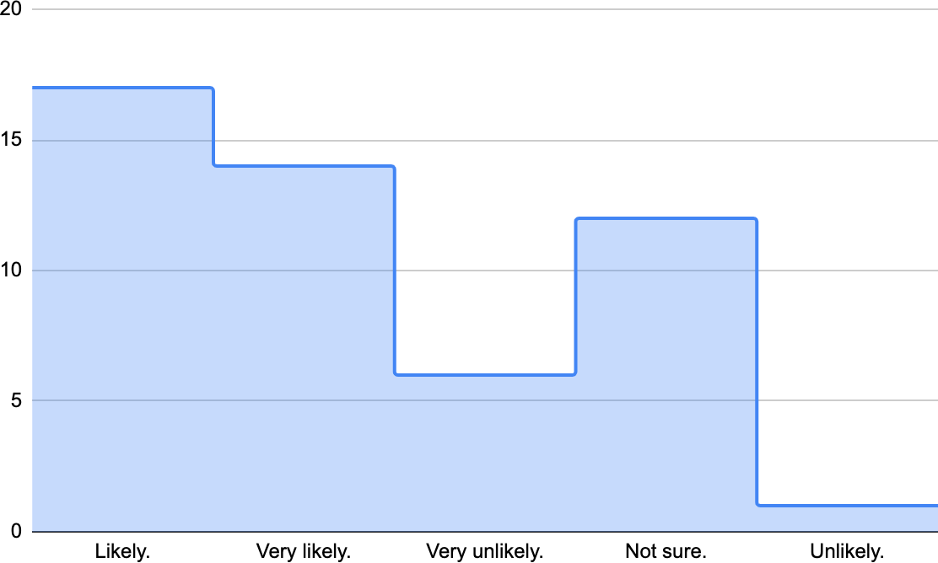

**Source:** Computed by the researcher

The graph above depicts the likelihood of respondents purchasing diversified cryptocurrency assets while considering future investments. where 17 are likely to purchase diversified cryptocurrencies (the highest) and 6 are very unlikely to purchase diversified cryptocurrencies (the least).

## Figure - 6.14

Cryptocurrencies as store of value

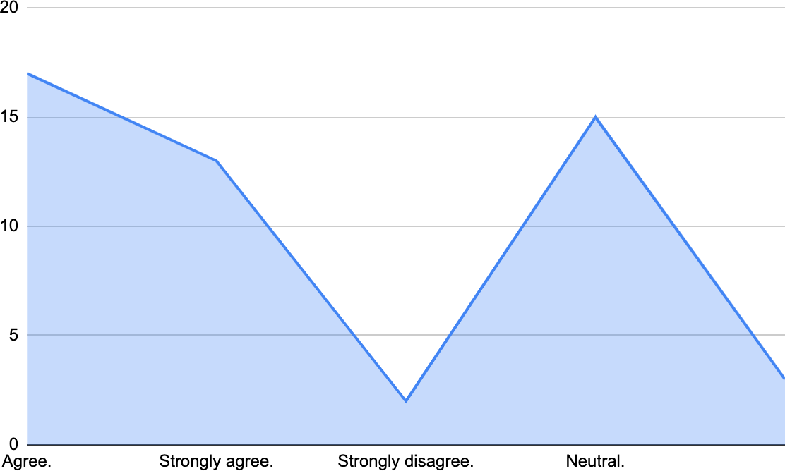

**Source:** Computed by the researcher

The graph above shows how many respondents agree or disagree that cryptocurrencies are more valuable as an investment than a form of payment. In which 17 agree (the highest) and 2 strongly disagree ( the least).

## Figure - 6.15

Factors influencing investor’s decision

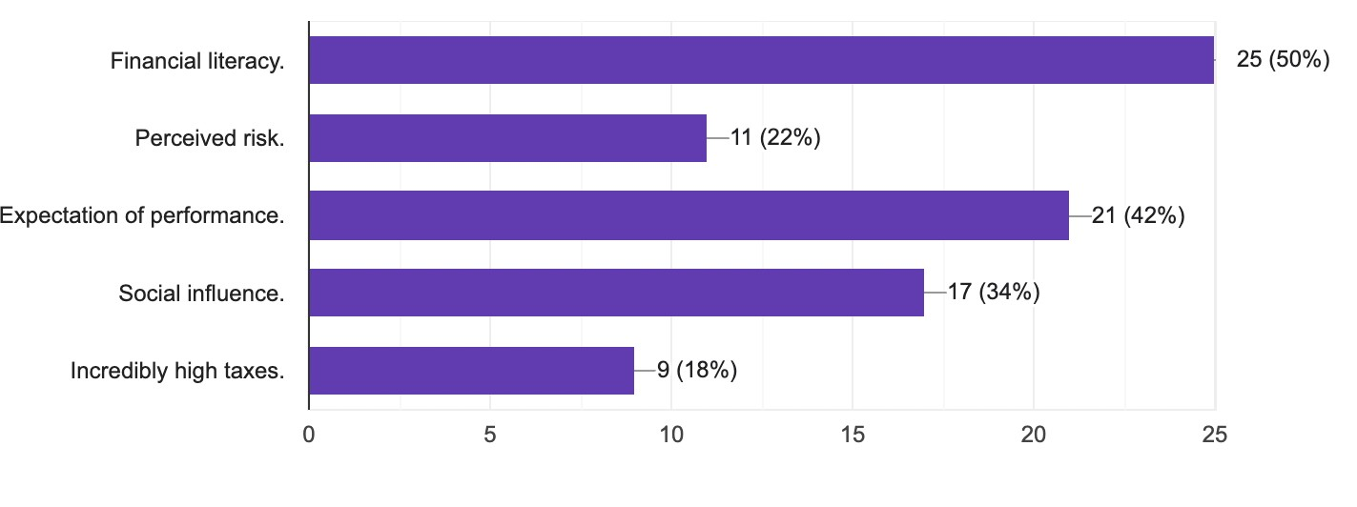

**Source:** Computed by the researcher

The chart above depicts the primary factors impacting investors' decisions about crypto currency investing in India. Whereas 25 respondents feel it is financial literacy (the highest) and 9 believe it is extremely high taxes (the least).

## Figure - 6.16

Future growth prospects

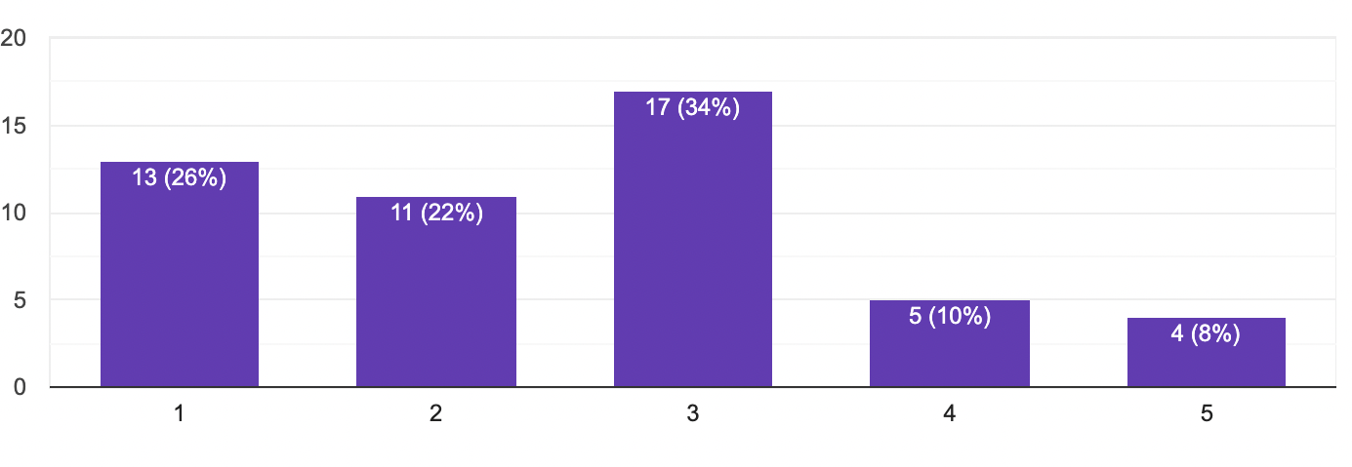

**Source:** Computed by the researcher

The graph above depicts how respondents believe cryptocurrencies will be valued more or less in five years. 34 percent are neutral, 26 percent believe it will be significantly more, 22 percent believe it will be more, 10 percent believe it will be less, and 8 percent believe it will be significantly less.

## Table - 6.3

|  |  |  |
| --- | --- | --- |
| **Cryptocurrencies** | **No of respondents** | **Percentage** |
| Bitcoin | 21 | 42% |
| Ethereum | 14 | 28% |
| Cardano | 4 | 8% |
| Binance coin | 4 | 8% |
| XRP | 3 | 6% |
| Solana | 2 | 4% |
| Shiba Inu | 1 | 2% |

**Figure - 6.17**

Speculation of future market leader

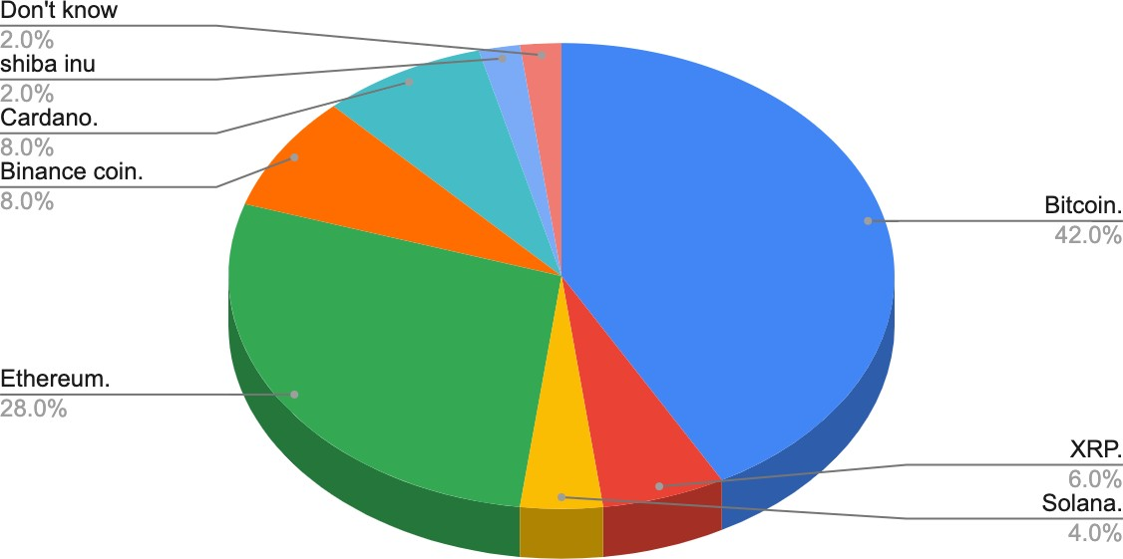

**Source:** Computed by the researcher

The pie chart above depicts the cryptocurrencies that will outperform in the future. Bitcoin and Ethereum have the highest weightages, at 42 and 28 percent, respectively. Only 2% of respondents believe Shiba Inu will perform better in the future (the least).

## Figure - 6.18

Use of crypto currencies for illegal purposes

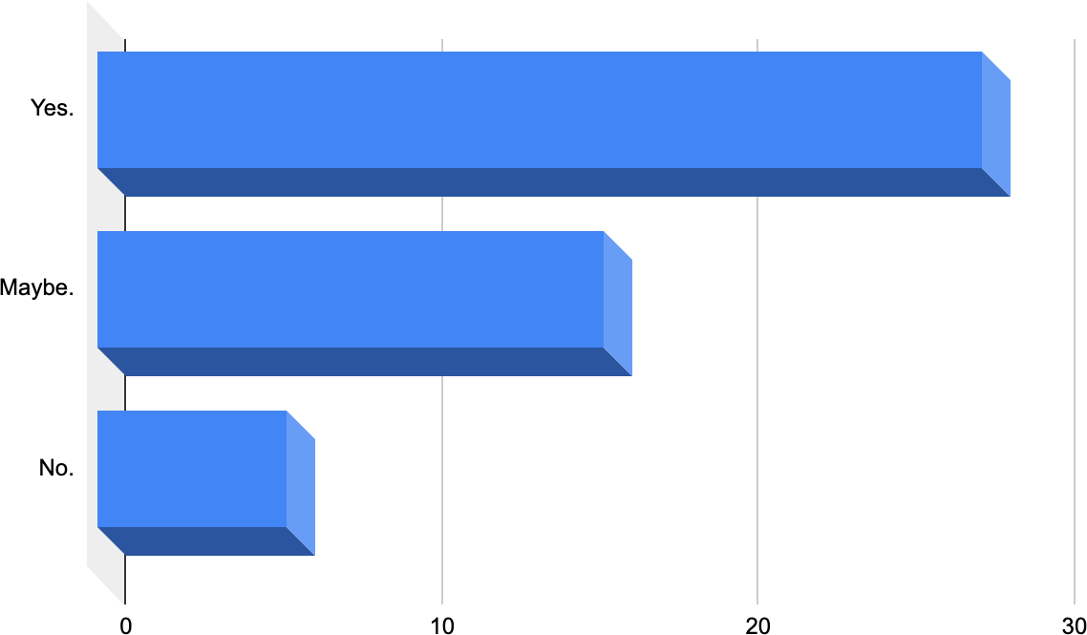

**Source:** Computed by the researcher

The graph above depicts how many respondents feel cryptocurrencies are used for illicit purposes. In which 56 percent believe cryptocurrencies are used for illegal purposes and 12 percent believe cryptocurrencies are not used for illegal purposes.

## Table - 6.4

|  |  |  |
| --- | --- | --- |
| **Platform** | **No of respondents** | **Percentage** |
| Coinbase | 8 | 16% |
| Binance | 14 | 28% |
| Gemini | 4 | 8% |
| Coin DCX | 24 | 48% |

**Figure - 6.19**

Platform preferences of people

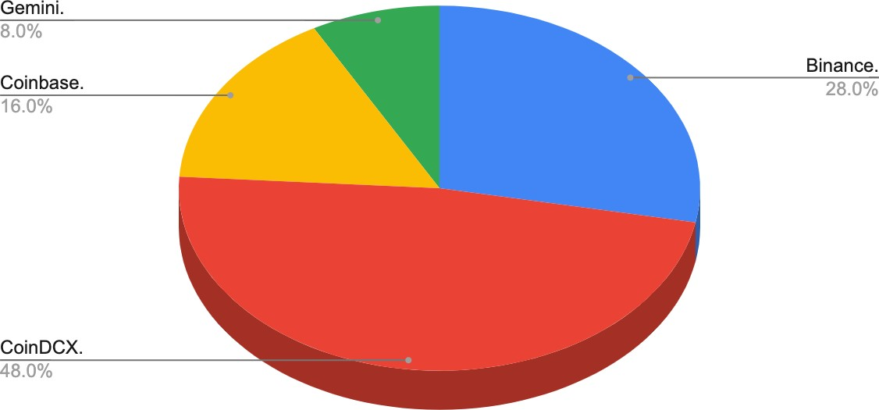

**Source:** Computed by the researcher

The chart above depicts the finest platform for investing in cryptocurrency. In which 48 % feel Coin DCX is the best (the highest) platform and 8 % believe Gemini is the best platform (the least).

## Figure - 6.20

Will Crypto eventually replace the current system?

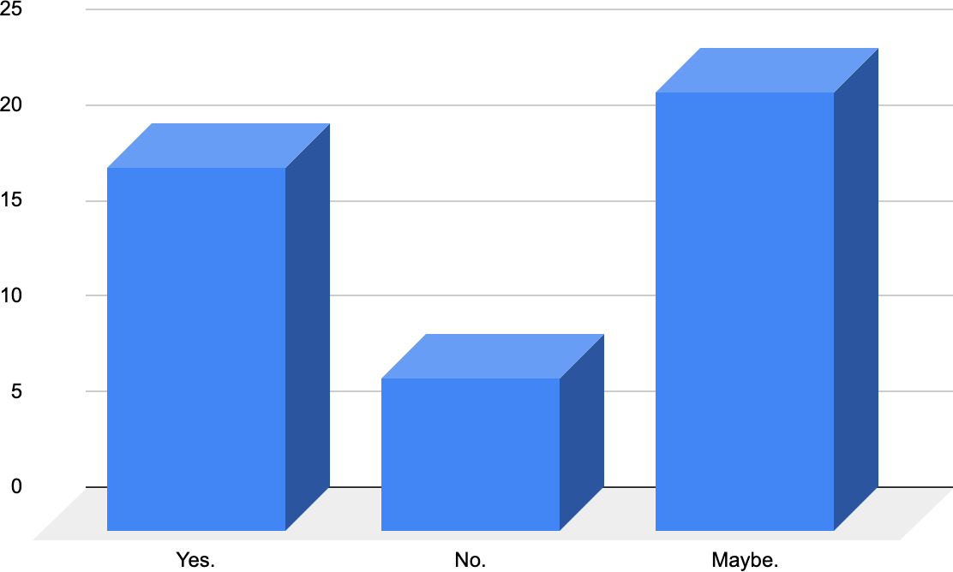

**Source:** Computed by the researcher

The graph above depicts the number of respondents that believe and do not believe that crypto currencies would eventually replace the present financial system. 19 believe crypto currencies will ultimately replace the present financial system, 8 do not believe crypto currencies will eventually replace the current financial system, and 23 are unsure.

## Correlation Matrix

**Figure - 6.21**

Correlation matrix

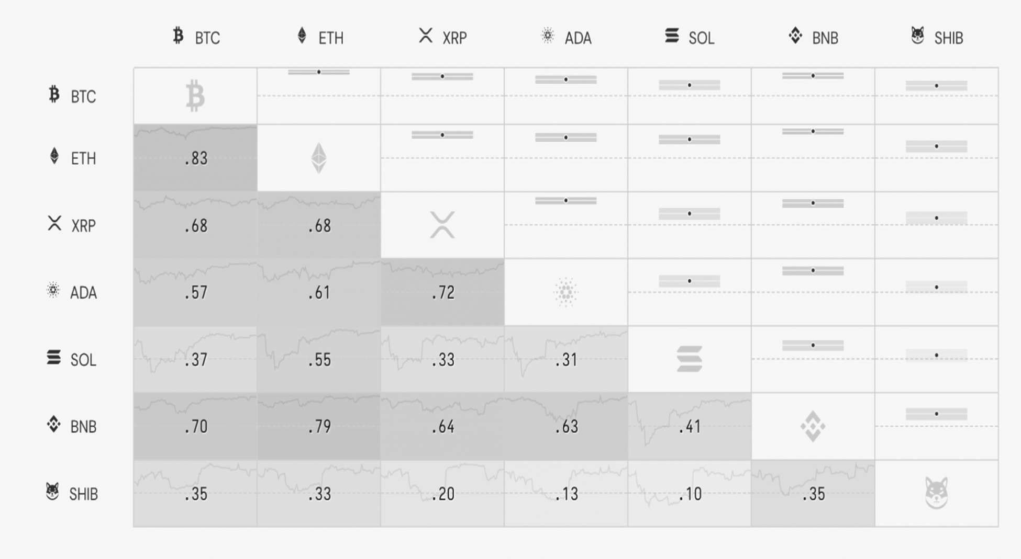

**Source:** Taken from the cryptowatch

**Correlation:**

Positively linked variables tend to move together, negatively correlated variables move in the opposite direction, and uncorrelated variables move separately.The above correlation matrix is based on data from the previous one year. The Pearson Correlation Coefficient estimates the strength of the linear relationship between two variables. Its value varies from

+1 to -1: A perfect positive linear correlation is shown by +1, a perfect negative linear correlation is indicated by -1, and no linear correlation is indicated by 0. The background figure depicts the evolution of the correlation over time (rolling correlation with a rolling window width of 20 data points). The Confidence Interval denotes the range within which the true Pearson correlation coefficient will be found with 95% probability. If the confidence interval contains the value zero (if crosses the dashed line), the correlation is considered non-significant (not different from 0).

## Bitcoin Historical Performance

**Figure - 6.22**

Bitcoin historical performance

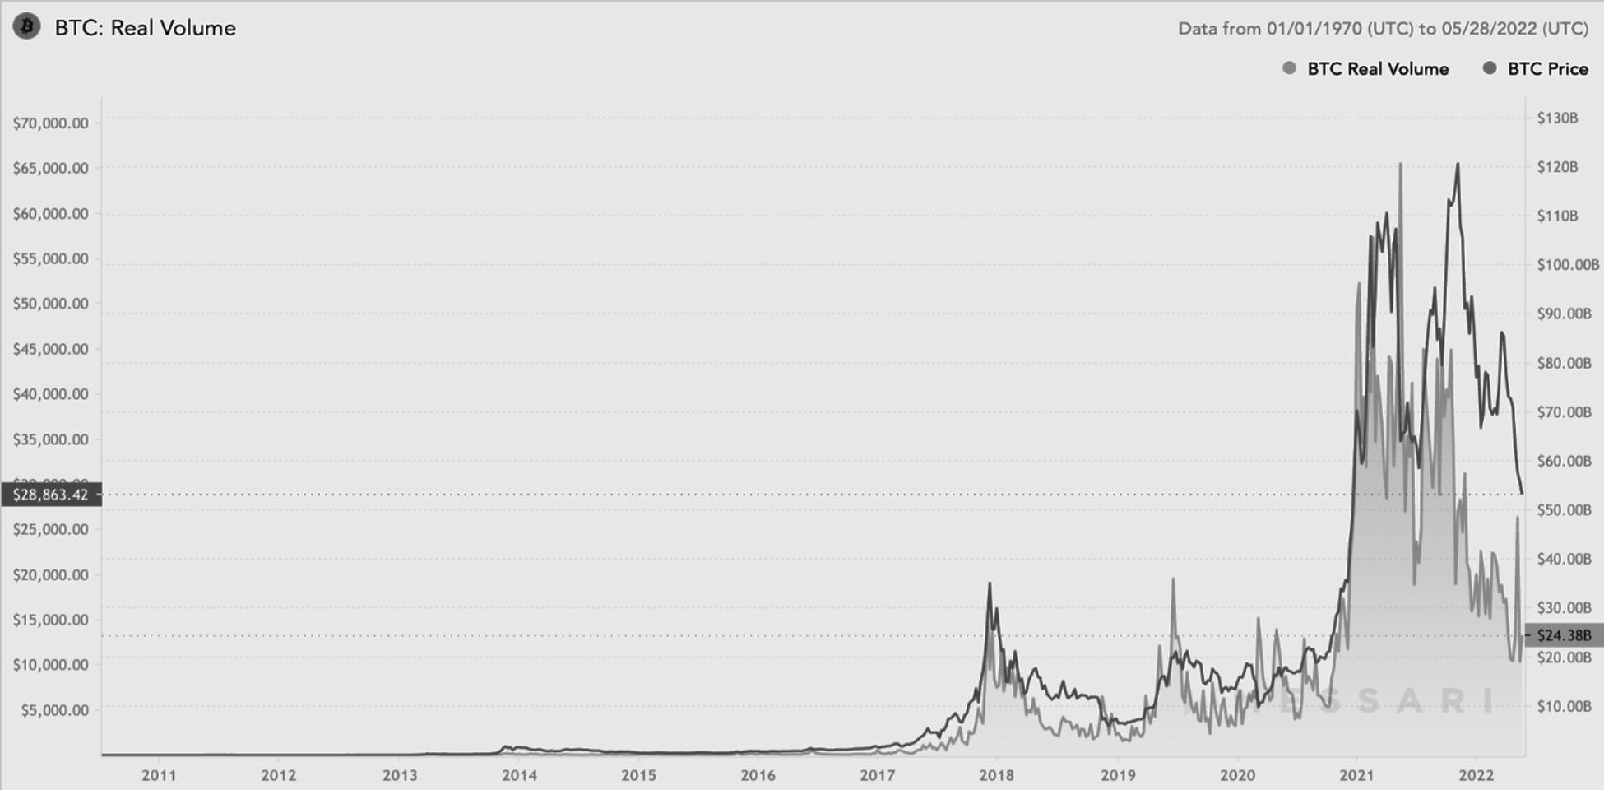

**Source:** Taken from the Messari

When Bitcoin was first launched in 2009, its price was zero. On July 17, 2010, its value increased to $.091. Bitcoin's price increased once more on April 13, 2011, from $1 to a high of $29.60 on June 7, 2011, a gain of 2,960 percent in three months. 4 Following a steep decline in cryptocurrency markets, Bitcoin's price fell below $2.05 by mid-November. 5 The price increased from $4.85 on May 9 to $13.50 by August the following year. Prices gradually increased throughout 2016, reaching over $900 by the end of the year. Bitcoin's price stayed around $1,000 throughout 2017 until it exceeded $2,000 in mid-May. Bitcoin broke its 2020 price record in less than a month in 2021, reaching $40,000 on January 7, 2021. As Coinbase, a cryptocurrency exchange, went public in mid-April, Bitcoin values reached fresh all-time highs of moreover $60,000. Bitcoin's price rose further as a result of institutional interest, reaching a high of $63,558 on April 12, 2021. Bitcoin's price fell gradually between January and May 2022, with closing prices reaching as high as $47,445 at the end of March before falling further. Bitcoin ended at $28,305 on May 11, its lowest price since July 20, 2021.

## Ethereum Historical Performance

**Figure - 6.23**

Ethereum historical performance

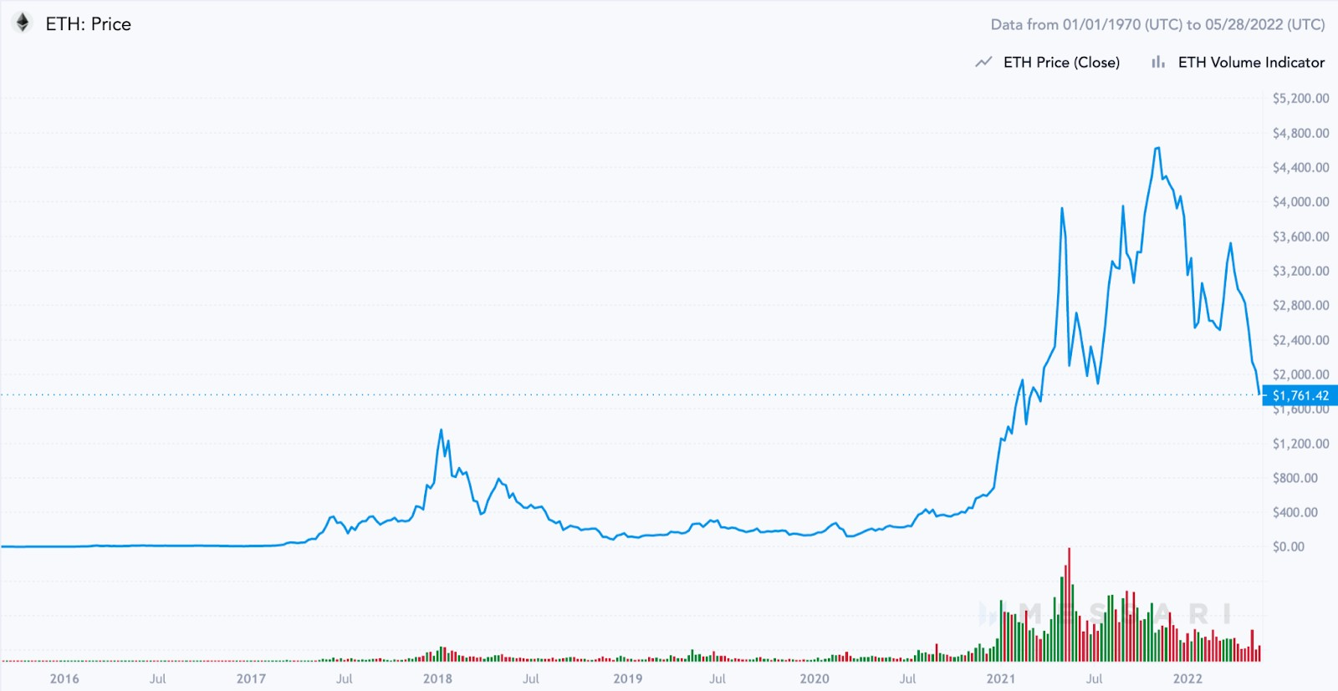

**Source:** Taken from the Messari

Ethereum released its native token, ether, in August 2014 via an initial coin offering (ICO). Over $16 million was raised for the initiative by selling 50 million ETHs at a price of $0.31 per coin.

From the token's initial debut date in 2014 until March 2017, the price ranged between $0.70 to $21. It wasn't until May of that year, when the 2017 bull crypto market began to heat up, that the price of ETH surpassed $100 for the first time. From there, ether soared to a high of

$414 in June 2017 before falling again. It took another five months for positive sentiment to return. By that moment, the whole crypto market was experiencing massive purchasing pressure, propelling practically every crypto coin to new highs. By January 2018, the price of ETH had reached $1,418 before plummeting drastically.

It took about three years for the second-largest cryptocurrency by market capitalization (behind bitcoin) to retest its previous all-time high price. Between February and May 2021, the price of ether more than quadrupled, reaching an all-time high of $4,379.

## Competitive Analysis

**Figure - 6.24**

Competitive analysis

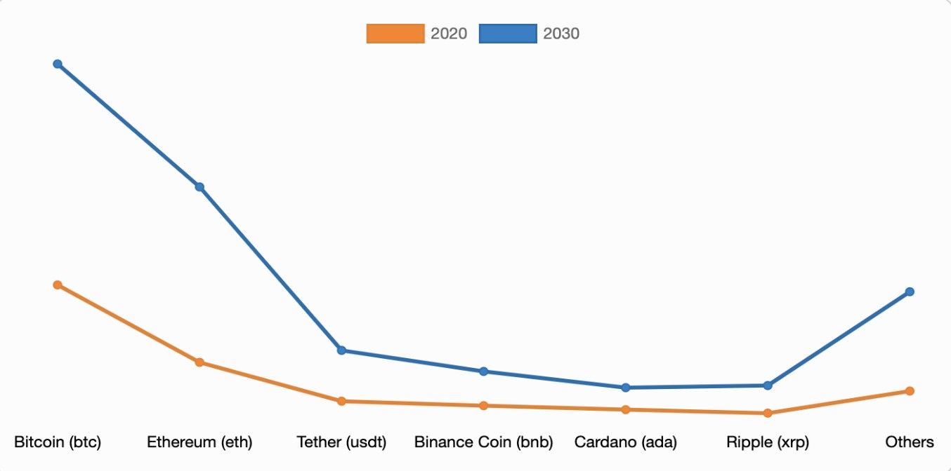

**Source:** Taken from Allied market research

Throughout the forecast period, the Bitcoin (BTC) segment will continue its lead. Advanced Micro Devices Inc., BitFury Group Limited, BTL Group Ltd., Coincheck Inc., Intel Corporation, Ledger SAS, NVIDIA Corporation, Ripple, Xilinx Inc., and Xapo Holdings Limited are among the prominent competitors mentioned in the market study. To enhance market penetration and improve their position in the cryptocurrency sector, these significant companies have used a variety of techniques, including product portfolio growth, mergers and acquisitions, partnerships, geographical expansion, and collaborations.

# Chapter - 7 Findings, Suggestions, and

**Conclusions**

## Findings

The study's major findings are summarized as follows:

According to the results, the majority of respondents (48%) feel they have knowledge about cryptocurrencies to some extent.

The majority of respondents (54%) have never held cryptocurrency, while just 32% currently hold them.

The majority of respondents learned about cryptocurrencies through social media platforms like Youtube, Twitter, and Instagram.

According to the results, when it comes to cryptocurrency investments, the majority of respondents may or may not accept the advice of others.

The majority of respondents want to invest in cryptocurrencies in order to diversify their entire portfolio, utilize blockchain technology, and support decentralized finance.

According to the data, the majority of respondents can't afford to lose all of their cryptocurrency investments, that they invested or if they wish to invest in the future. When considering their future investing goals, the majority of respondents are likely to invest in cryptocurrencies.

Cryptocurrencies are more valuable as an investment than as a means of payment, according to the majority of respondents.

Bitcoin and Ethereum, according to the majority of respondents, are the two major cryptocurrencies that will perform better in the future.

The majority of people think cryptocurrency are used for illegal purposes.

Cryptocurrencies may or may not replace the present financial system, according to 46% of respondents, and cryptocurrencies will replace the current financial system, according to 38% of respondents.

According to the research, the biggest factor influencing investors' decision-making process in cryptocurrency investing in India is a lack of financial literacy, as per majority of respondents.

## Suggestions

It's not simple to tell the difference between real cryptocurrency recommendations and scammers; there are plenty of sharks ready to grab your money. Take a step back from the hype when you're presented with a lot of information about a cryptocurrency. Examine the project or platform critically.

Some persons who provide crypto trading advice may not be looking out for your best interests. So don't make the same mistakes as others and be stung. Set boundaries on how much you invest in a specific digital currency, and don't risk more money than you can afford to lose by trading with it. Trading cryptocurrencies is a high-risk profession, with more traders losing money than making money.

It's not a good idea to put too much money into a single cryptocurrency. Don't put all your eggs in one basket, as they say. Spread your money across multiple digital currencies, just like you would with equities and shares. This means you won't be over-exposed if one of them loses value, which is especially important given how unpredictable these assets' market values are.

Prices fluctuate rapidly from day to day, and inexperienced traders are sometimes fooled into panic selling when prices are low. Cryptocurrencies aren't going away anytime soon. Investing in the crypto market for months or years at a time may yield the finest results.

Low pricing does not necessarily imply a good deal. Prices are sometimes cheap for a reason! Keep an eye out for coins with dwindling user numbers. Frequently, developers abandon a project, and it ceases to be maintained, rendering the coin vulnerable.

Making money by trading any type of financial instrument, whether stocks and shares or commodities like silver and gold, is not simple. Cryptocurrency is in the same boat. Anyone who claims otherwise is most likely attempting to mislead you into making crypto blunders.

Criminals may quickly inflate or deflate the price of extremely tiny or unknown coins, sending their value surging in some cases. Criminals may hold a large amount of a cryptocurrency at any given moment (through pre-mining much of it before it is available to the general public). When unknowing traders rush in to attempt to get a

piece of the action, the crooks wait for the price to rise before selling all of their coins, causing the price to plummet. They might inflate the price by marketing it on social media before selling it for more.

Some of the more dubious trading platforms advise you to bet as much as possible in order to maximize your profits. This is a fast track to the poorhouse. Better crypto investment advice would be to limit your investment money to a particular percentage, say, 5% and to have an emergency cash reserve in an easy-to-access savings account that is never involved in the market.

## Conclusions

In the global financial system, cryptocurrencies are a hot topic. Cryptocurrency exchange rates are quite volatile. Trading these cryptocurrencies has a significant risk as a result of this many speculators have been interested in their progress. They are portable. Only once cryptocurrencies have gained the necessary trust will they be used on a larger scale. If cryptocurrencies do not achieve this trust, their rise may be halted. They are still in their infancy.

This study showed me in understanding the variables that influence investors' decision-making processes when it comes to cryptocurrency investing in India. The majority of individuals want to invest in cryptocurrencies to diversify their portfolio, use blockchain technology, and promote decentralized finance, according to the findings of this questionnaire. Bitcoin and Ethereum are thought to be the two major Cryptocurrencies that will perform better in the future. This experience has given me a better understanding of cryptocurrencies in India and the public's perspective of them.

## Bibliography

Al-Mansour, Bashar.Y (2020), Crypto currency Market: Behavioral Finance Perspective, The Journal of Asian Finance, Economics, & Business, volume 7, issue 12, p 159-168.

Anu.B (2022), Crypto currency and its scope in India, International Journal of Innovative Research In Technology, volume 8, issue 8, ISSN 2349-6002, P 593-596.

A.Can Inci & Rachel.L (2019), Cryptocurrencies: applications and investment opportunities, Journal of Capital Market Studies, volume 3, issue 2, ISSN 2514-4774, p 98-112.

Aman.K, Rehman.A, & Muqadas.K (2021), Investor Perception of Cryptocurrency: A Moderating Role of Social Media on Decision-Making, Global Economics Review, volume 6, issue 4, p 136-149.

Bhuvana.R & Aithal.P.S (2022), Investors Behavioral Intention of Crypto currency Adoption– A Review based Research Agenda, International Journal of Applied Engineering and Management, volume 6, ISSN 2581-7000, p 126-148.

Bella.S.N & Gatot.S (2022), Determinants of Investment Decision in Cryptocurrency: Evidence from Investors, Universal Journal of Accounting and Finance, volume 10, issue 1, p 254-266.

David.L.K.C, Li.G, & Yu.W (2018), Cryptocurrency: A New Investment Opportunity?, Journal of Alternative Investments, volume 20, issue 3, p 16-40.

Giancarlo.G, Alistair.M, & Dmitri.V (2019), Crypto currencies: market analysis and perspectives, Journal of Industrial and Business Economics, volume 47, p 1-18.

Jon.T (2018), decarbonizing bitcoin: law and policy choices for reducing the energy consumption of blockchain technologies and digital currencies, Science Direct, volume 44, p 399-410.

Jay.D, Muskan.G, Shivani.V, Mansi.P, Aditi.M, & Nakul.K (2020), A Research Study on Awareness Regarding Crypto Currency Among Investors, [International Journal on](https://www.neliti.com/journals/ijie) [Integrated Education](https://www.neliti.com/journals/ijie), volume 3, issue 3, ISSN 2620-3502, p 114-125.

Mario.A.O, Jorge.P.B & Gustavo.M.C (2019), variables influencing crypto currency use : A technology acceptance model,frontiers in psychology, volume 10, p 1-10.

Mohammad.H.J, Yuka.N & Krishnan.D (2019), crypto currency, a successful application of blockchain technology, Managerial Finance, volume 46, issue 6, ISSN 0307-4358, p 715-733.

Prepathon.J , Suchira.M, Syeda.N.G & Owais.S (2022), factors influencing the behavioral intention to use crypto currency in emerging economies during the COVID-19 pandemic: Based on technology acceptance model 3, perceived risk, and financial literacy, frontiers in psychology, volume 12, p 1-12.

Peter.D.D (2016), An Analysis of Cryptocurrency, Bitcoin, and the Future, International Journal of Business Management and Commerce, volume 1, p 1-10.

Paul.D, Daniel.L.K, & Jennifer.W (2021), The psychology of cryptocurrency trading: Risk and protective factors, Journal of Behavioral Addictions, volume 10, issue 2, p 201-207.

Ryan.F (2015), an analysis of the crypto currency industry, Wharton research scholars, volume 23, p 1-23.

Rainer.B, Nicolas.C, Benjamin.E, & Tyler.M (2015), Bitcoin: Economics, Technology, and Governance, Journal of Economic Perspectives, volume 29, issue 2, p 213-238.

Saeed.A & Tugrul.D (2019), analysis of the crypto currency adoption decision, Portland International Conference on Management of Engineering and Technology (PICMET), volume 11, p 1-11.

Swati.G, Sanjay.G, Manoj.M & Hanumantha.R.S (2021), prioritizing of the intentions behind investment in crypto currency: a fuzzy analytical framework, journal of economic studies, volume 48, ISSN 0144-3585, P 1442-1459.

Salim.L & Stelios.B (2020), impact of COVID-19 pandemic upon stability and sequential irregularity of crypto currency markets, chaos, solitons & fractals, volume 138, ISSN 109936, P 1-138.

Sabrina.T.H, Marina.N & David.Y (2020), initial coin offerings: Financing growth with crypto currency token sales, The Review of Financial Studies, volume 33, issue 9, p 3925-3974.

Sunita D (2021), Analysis of Return and Risk of Cryptocurrency Bitcoin Asset as Investment Instrument, Accounting and finance innovations, volume 15, p 1-15.

Yilmaz.N.K & Hazar.H.B (2018), Determination of the factors affecting investors' decision making process in crypto currency investments, PressAcademia Procedia, Volume 8, ISSN 2459-0762, P 5-8.

## References

[www.pressacademia.org](http://www.pressacademia.org/) pdxscholar.library.pdx.edu [www.emrald.com](http://www.emrald.com/)

[www.frontiersin.org](http://www.frontiersin.org/)

[www.scienceopen.com](http://www.scienceopen.com/) [www.elsevier.com](http://www.elsevier.com/) repository.upenn.edu

[www.sciencedirect.com](http://www.sciencedirect.com/)

academic.oup.com

[www.intechopen.com](http://www.intechopen.com/) [www.koreascience.or.kr](http://www.koreascience.or.kr/) ijbmcnet.com link.springer.com ijirt.org srinivaspublication.com [www.neliti.com](http://www.neliti.com/) ink.library.smu.edu. turcomat.org

[www.Academia.edu](http://www.Academia.edu/) link.springer.com

[www.gerjournal.com](http://www.gerjournal.com/) akjournals.com pubs.aeaweb.org

## Appendix

**Questionnaire**

1. What is your gender?

* Male
* Female
* Other

1. What is your age?

* 20 & under
* 21 - 29
* 30 - 39
* 40 - 49
* 50 - 59
* 60 & 0ver

1. What is your occupation?

* Self employed
* Salaried
* Student
* Other

1. Which of the following best represents your annual personal income range?

* < ₹2.5 lakh
* ₹2.5 lakh - ₹5 lakh
* ₹5 lakh - ₹10 lakh
* > ₹10 lakh

1. How well do you believe you know about cryptocurrencies?

* Very well
* To some extent
* Not very well
* Not at all

1. Which one of the following sentences best describes your situation?

* I presently own cryptocurrency
* I've previously held cryptocurrency
* I've never owned cryptocurrency

1. What was your first exposure to cryptocurrencies?

* Online articles, such as blogs, & news websites etc
* Social media platforms, such as Youtube, Twitter, & Instagram etc
* General conversations with non-experts such as friends, family, & colleagues
* General conversations with financial or digital specialists
* Other

1. Do you follow the advice of others when it comes to cryptocurrency investments?

* Yes
* No
* Maybe

1. Why did or will you invest in cryptocurrencies?

* Fear of missing out ( FOMO)
* To use blockchain technology and to promote decentralized finance
* To be used as a payment method for online transactions
* To make domestic or cross-border money transactions
* To diversify the overall investment portfolio
* Other

1. What do you do if the price of cryptocurrency assets falls which you purchased or if you want to purchase them in future?

* I'm going to buy the dip
* I'm going to sell those cryptocurrencies
* I'm not going to do anything

1. Can you afford to lose all of your cryptocurrency that you have invested or if you want to invest in the future?

* Yes
* No
* Maybe

1. How likely are you going to purchase cryptocurrency assets while thinking about your future investments?

* Very likely
* Likely
* Neutral
* Unlikely
* Very unlikely

1. How likely are you going to purchase diversified cryptocurrencies while thinking about your future investments?

* Very likely
* Likely
* Not sure
* Unlikely
* Very unlikely

1. Cryptocurrencies are more valuable as an investment than a means of payment. To what extent do you agree or disagree with the statement?

* Strongly agree
* Agree
* Neutral
* Disagree
* Strongly disagree

1. What are the main variables influencing investors' decision-making in cryptocurrency investment in India?

* Financial literacy
* Perceived risk
* Expectation of performance
* Social influence
* Incredibly high taxes

1. In five years, do you think cryptocurrency will be worth more or less than today?

* Significantly more
* More
* Neutral
* Less
* Significantly less

1. According to you which cryptocurrency will perform better in future?

* Bitcoin
* Ethereum
* Cardano
* Binance coin
* XRP
* Solana
* Other

1. Do you believe that cryptocurrencies are used for illegal purposes?

* Yes
* No
* Maybe

1. Which platform do you think is the best for investing in cryptocurrencies?

* Coinbase
* Binance
* Gemini
* CoinDCX

1. Do you believe that cryptocurrencies will eventually replace the current financial system?

* Yes
* No
* Maybe